Central Mountain Training Region

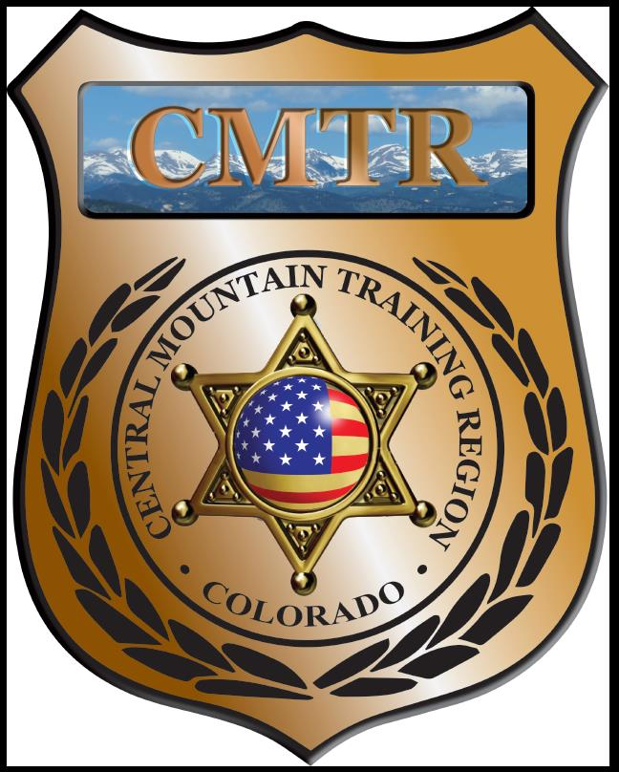

Meeting Agenda
May 3rd, 2018
11:00am

Host:
Canon City PD
128 Main St
Canon City, CO 81212

Meeting Agenda

CMTR Board Members
- President: Mike Rulo Cripple Creek PD
- 1st Vice President: Shelli Ellis Pueblo PD
- 2nd Vice President: Cory Schafer El Paso County S.O.
- 3rd Vice President: Shannon Byerly Custer County S.O.
- Secretary: Chris Adams Woodland Park PD
- Assistant Secretary: Russ Johnson Salida PD
- Voting Position: Janie Anderson Colorado Springs PD
- Regional Training Coordinator: Jason Smith Pueblo PD

Welcome: New Faces and Guests

Treasurer’s Report: (Jason Smith)

Training
- Started with $75,694.38
- Classes held and scheduled $53,703.91
- Moved $10,000 to equipment, moved $1,600 to Scholarships, $5,000 equipment
- Remaining balance of $7958.31

Equipment
- Started with $80,742
- Spent $49,884.29
- Deposited $41,306 from Scholarships and Training
- Pending charges; Target system $64,240
- Remaining balance $2033.77

Scholarships
- Started with $80,742
- Given 53 scholarships out totaling $50,679.40
- Transferred $31,306 to Equipment
- Remaining balance $650.30

We have a total of $10,642.38 left from the above line items.

Old Business

No news on the reimbursement for Neal on the 1099’s and W-2’s.

POST Grant Application has been turned in.

Board voted No on the Scholarships for the Wicklander-Zulawski training.

Board voted Yes on using extra money for UTM munitions, AR bolts and pistols, medical bag and fire-extinguisher, cabinet for driving trailer.

New Business

- 2018-19 Grant Application has been turned in.
- New Website tabs have been added; Instructors, equipment and range availability.
- Salida PD sent information on a Suicide Prevention for Law Enforcement by Lt John Coppedge, Denver, PD ($1000)
- Level II TA Investigation coming up May 14-25.
- Custer County SO turned in Lesson Plan for an ammo request
- July 5th meeting, do we want to change it because of holiday.
- Nominations for open position on the Board

Training Request
Remaining Balance: $0
- From Agency:
  - For (Officer):
  - Class:
  - Date Requested:
  - Date(s):
  - Location:
  - Class Cost: $0
  - Lodging: $0
  - Per Diem: $0
    - To: Action:
  - Related Cost: $0

Total Cost: $
Vote:
Rulo Y/N, Ellis Y/N, Schafer Y/N, Byerly Y/N, Adams Y/N, Johnson Y/N, Anderson Y/N

Other Items to Discuss:

Notes:_______________________________________________________________________________________________________________________________________________________________________________________________________________________________________________________________________________________________________________________________________________________________________________________________
Central Mountain Training Region
Meeting Schedule 2017/18
(First Thursday of the Month) Start Time 10:00am

June 7th, 2018 (Annual Meeting / Elections) Location / Host:
Pueblo County Sheriff’s Office
729 Gold Dr
Pueblo West, CO 81007
July 5th, 2018 Location / Host:
Woodland Park Police Dept
911 Tamarac Pkwy
Woodland Park, CO 80863
August 2nd, 2018 Location / Host:
Fountain Police Dept
222 N Santa Fe Ave
Fountain, CO 80817
September 6th, 2018 Location/Host:
Colorado Springs PD Training Academy
725 N Murray Blvd
Colorado Springs, CO 80915
October 4th, 2018 Location/Host:
Salida Police Department
448 E 1st St
Salida, CO 81201

November 1st, 2018 Location/Host:
Pueblo County Sheriff’s Office
909 Court St
Pueblo, CO 81003
December 6th, 2018 Location/Host:
Manitou Springs Police Department
606 Manitou Ave
Manitou Springs, CO 80829

