Central Mountain Training Region

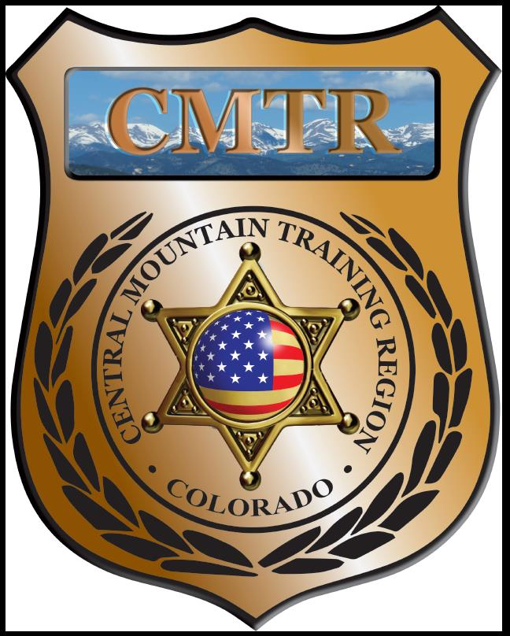

Meeting Agenda
June 7th, 2018
11:00am

Host:
Pueblo County SO
729 Gold Dr
Pueblo West, CO 81007

Meeting Agenda

CMTR Board Members
- President: Mike Rulo Cripple Creek PD
- 1st Vice President: Shelli Ellis Pueblo PD
- 2nd Vice President: Cory Schafer El Paso County S.O.
- 3rd Vice President: Shannon Byerly Custer County S.O.
- Secretary: Chris Adams Woodland Park PD
- Assistant Secretary: Russ Johnson Salida PD
- Voting Position: Janie Anderson Colorado Springs PD
- Regional Training Coordinator: Jason Smith Pueblo PD

Welcome: New Faces and Guests

Treasurer’s Report: (Jason Smith)

Training
- Started with $75,694.38
- Actuals Paid $52,909.72, Actuals Unpaid $1,437.60
- Moved $16,600 to Equipment
- Remaining balance of
- $4,747.06

Equipment
- Started with $80,742
- Deposited $41,306 from Scholarships and Training
- Deposited $5,000 from Training
- Posted Grant an extra $24,502.50, totaling $151,550.50
- Spent $147,461.99
- Remaining balance $4,088.51

Scholarships
- Started with $80,742
- Moved $31,306 to Equipment
- Deposited $1,600 from Training
- Scholarships $47,610.70
- Remaining balance $3425.30
- Pending $1,405 (3 Scholarships)

We have a total of $10,240.57 left from the above line items to buy UTM equipment.

Old Business

2018-19 Grant Application has been turned in. Waiting for approval.
New Website tabs have been added; Instructors, equipment and range availability.
Custer County SO ammo request was approved by Board.
July meeting moved to the 12th.

New Business

- 2018-19 Grant Application has been turned in and return. Granted Total $274,650. Training $131,522, Equipment $72,647.48, Scholarships $34,656.52, Grant Management $11,941 and Program Delivery $23,883.
- New Website; www.cmtrtraining.org. is up and running. Garcie Survival Tactics for LE is posted (July 25-26)
- Pueblo PD wanting to run a Basic SWAT School July 30th-August 3rd.
- Nomination for open position on the Advisory Board. Assistant Secretary and 2 voting positions.

Training Request
Remaining Balance: $0
- From Agency: Pikes Peak Community College
  - For (Officer): Ronald Martinez
  - Class: National School Safety Symposium
  - Date Requested: 05-15-18
  - Date(s): July 8th-11th, 2018
  - Location: Thornton, CO
  - Class Cost: $350
  - Lodging: $0
  - Per Diem: $0
    - To: Action:
  - Related Cost: $0
Approved 06/07/18

Total Cost: $350
Vote:
Rulo Y/N, Ellis Y/N, Schafer Y/N, Byerly Y/N, Adams Y/N, Johnson Y/N, Anderson Y/N

- From Agency: Pueblo Police Department
  - For (Officer): Nick Lile
  - Class: Forensic Pathology for Homicide Investigation
  - Date Requested: May 15th, 2018
  - Date(s): August 21st-22nd, 2018
  - Location: Denver, CO
  - Class Cost: $350
  - Lodging: $360
  - Per Diem: $44
    - To: Nick Lile Action:
  - Related Cost: $0
Approved 06/07/18

Total Cost: $754
Vote:
Rulo Y/N, Ellis Y/N, Schafer Y/N, Byerly Y/N, Adams Y/N, Johnson Y/N, Anderson Y/N

- From Agency: Pueblo Police Dept
  - For (Officer): Kenny Rider
  - Class: Rocky Mountain Accreditation Network Conference
  - Date Requested: May 18th, 2018
  - Date(s): October 15th-16th, 2018
  - Location: Avon, CO
  - Class Cost: $0
  - Lodging: $280
  - Per Diem: $40
    - To: Kenny Rider Action:
  - Related Cost: $30 (parking)
Approved 06/07/18

Total Cost: $350
Vote:
Rulo Y/N, Ellis Y/N, Schafer Y/N, Byerly Y/N, Adams Y/N, Johnson Y/N, Anderson Y/N

- From Agency: Pueblo Police Dept
  - For (Officer): Kathy LaConte
  - Class: Rocky Mountain Accreditation Network Conference
  - Date Requested: May 18th, 2018
  - Date(s): October 15th-16th, 2018
  - Location: Avon, CO
  - Class Cost: $0
  - Lodging: $280
  - Per Diem: $40
    - To: Kathy LaConte Action:
  - Related Cost: $30 (parking)
Approved 06/07/18

Total Cost: $350
Other Items to Discuss:

Notes:____________________________________________________________________________________________________________________________________________________________________________________________________________________________________
Central Mountain Training Region
Meeting Schedule 2017/18
(First Thursday of the Month) Start Time 10:00am

June 7th, 2018 (Annual Meeting / Elections) Location / Host:
Pueblo County Sheriff’s Office
729 Gold Dr
Pueblo West, CO 81007
July 12th, 2018 Location / Host:
Woodland Park Police Dept
911 Tamarac Pkwy
Woodland Park, CO 80863
August 2nd, 2018 Location / Host:
Fountain Police Dept
222 N Santa Fe Ave
Fountain, CO 80817
September 6th, 2018 Location/Host:
Colorado Springs PD Training Academy
725 N Murray Blvd
Colorado Springs, CO 80915
October 4th, 2018 Location/Host:
Salida Police Department
448 E 1st St
Salida, CO 81201

November 1st, 2018 Location/Host:
Pueblo County Sheriff’s Office
909 Court St
Pueblo, CO 81003
December 6th, 2018 Location/Host:
Manitou Springs Police Department
606 Manitou Ave
Manitou Springs, CO 80829

