Central Mountain Training Region

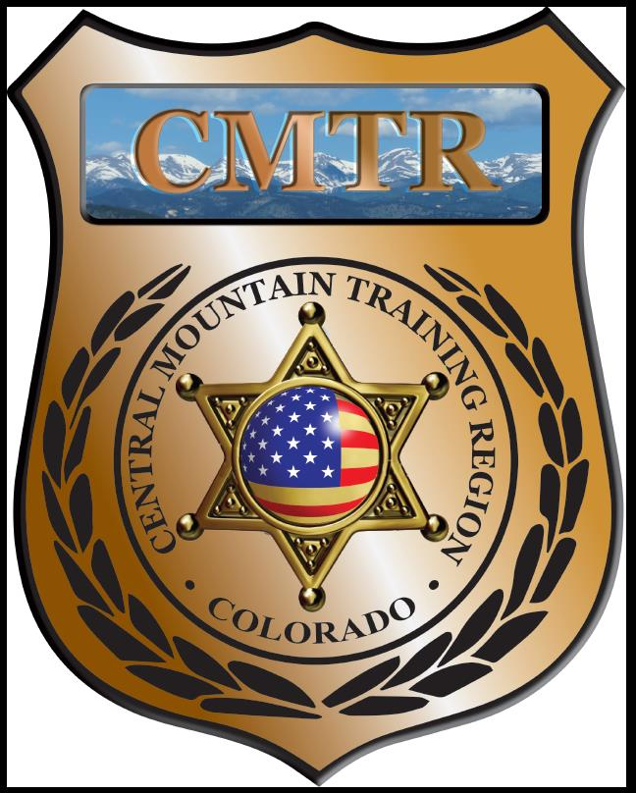

Meeting Agenda
February 7th, 2019
11:00am

Host:
Fountain Police Department
222 N Santa Fe Ave
Fountain, CO 80817

Meeting Agenda

CMTR Board Members
- President: Shelli Ellis Pueblo PD
- 1st Vice President: Shannon Byerly Custer County S.O.
- Secretary: Chris Adams Woodland Park PD
- Assistant Secretary: Russ Johnson Salida PD
- Voting Position: Janie Anderson Colorado Springs PD
- Voting Position: Chad Bauer Pikes Peak Community College
- Voting Position: Dave Clements Pueblo County SO
- Regional Training Coordinator: Jason Smith Pueblo PD

Welcome: New Faces and Guests
Treasurer’s Report: (Jason Smith)

Training
- Started with $135,334.48
- Train the Trainer $7,124.94, Level I TA $6,525.89
- Balance $75,633.35

Equipment
- Started with $68,835
- Balance $32,871

Scholarships
- Started with $34,656.52
- 4 scholarships were approved in January ($1780)
- Remaining $19,821.43

Old Business
- Taking surplus ammo to American Hunting and Firearms Service in Salida to trade next week
- Train the Trainers class starting in Fountain January 7th (full)
- Level I Traffic Accident starting in Pueblo January 14th (open slots)
- New Courses; Gracie Survival Tactics (Feb 27-Mar1), AR-15 Builders Course (May 13th)
- Any classes that are needed; FTO, Spanish for LE, Hostage Negotiator, etc
- Meeting locations for July-December 2019.

New Business
- AR Builders Course May 13th (4 out 12)
- Survitec Inflatable Wall
- NASRO is the prefered SRO Course by POST
- CIT Course next cycle.
- Advisory Board Terms
Training Request
Remaining Balance: $19,821.43

- From Agency: Pikes Peak Community College
  - For (Officer): Doug Zurek
  - Class: Taking the Lead: Courageous Leadership for Today’s Public Safety
  - Date Requested:
  - Date(s): March 1st, 2019
  - Location: Denver Sheriff’s Academy
  - Class Cost: $195
  - Lodging: $0
  - Per Diem: $0
    - To: Action:
  - Related Cost: $0
Approved

Total Cost: $
Vote:
Ellis Y/N, Byerly Y/N, Adams Y/N, Johnson Y/N, Anderson Y/N, Bauer Y/N, Clements Y/N

- From Agency: Pikes Peak Community College
  - For (Officer): John Orndorff
  - Class: Taking the Lead: Courageous Leadership for Today’s Public Safety
  - Date Requested:
  - Date(s): March 1st, 2019
  - Location: Denver Sheriff’s Academy
  - Class Cost: $195
  - Lodging: $0
  - Per Diem: $0
    - To: Action:
  - Related Cost: $0
Approved

Total Cost: $
Vote:
Ellis Y/N, Byerly Y/N, Adams Y/N, Johnson Y/N, Anderson Y/N, Bauer Y/N, Clements Y/N

- From Agency: Fountain Police Department
  - For (Officer): Brendan Murt
  - Class: Krav Maga Instructor Course
  - Date Requested: January 8th, 2019
  - Date(s): February 11-15, 2019
  - Location: Broomfield, CO
  - Class Cost: $825
  - Lodging: $0
  - Per Diem: $0
    - To: Action:
  - Related Cost: $0
Fountain PD removed request

Total Cost: $
Vote:
Ellis Y/N, Byerly Y/N, Adams Y/N, Johnson Y/N, Anderson Y/N, Bauer Y/N, Clements Y/N

- From Agency: Florence Police Department
  - For (Officer): Shane Prickett
  - Class: FBI LEEDA- Supervisor Leadership Institute
  - Date Requested: January 9th, 2019
  - Date(s): May 13-17, 2019
  - Location: Boulder County Sheriff’s Office
  - Class Cost: $695
  - Lodging: $0
  - Per Diem: $0
    - To: Action:
  - Related Cost: $0
Approved

Total Cost: $695
Vote:
Ellis Y/N, Byerly Y/N, Adams Y/N, Johnson Y/N, Anderson Y/N, Bauer Y/N, Clements Y/N

- From Agency: Florence Police Department
  - For (Officer): Patrick Slattery
  - Class: FBI LEEDA- Supervisor Leadership Institute
  - Date Requested: January 9th, 2019
  - Date(s): May 13-17, 2019
  - Location: Boulder County Sheriff’s Office
  - Class Cost: $695
  - Lodging: $1083
  - Per Diem: $0
    - To: Action:
  - Related Cost: $0
Approved/Reg Only

Total Cost: $695
Vote:
Ellis Y/N, Byerly Y/N, Adams Y/N, Johnson Y/N, Anderson Y/N, Bauer Y/N, Clements Y/N
- From Agency: Woodland Park Police Department
  - For (Officer): Tommie Belz
  - Class: Forensic Interviewing of Children
  - Date Requested: January 9th, 2019
  - Date(s): February 11-15, 2019
  - Location: Huntsville, AL
  - Class Cost: $1299
  - Lodging: $470
  - Per Diem: $220
    - To: Action:
  - Related Cost: $548.63 (flight)
Approved/Reg Only

Total Cost: $1299
Vote:
Ellis Y/N, Byerly Y/N, Adams Y/N, Johnson Y/N, Anderson Y/N, Bauer Y/N, Clements Y/N
- From Agency: Fountain Police Department
  - For (Officer): Tara Mallet
  - Class: Colorado Springs Management Course
  - Date Requested: January 15th, 2019
  - Date(s): March 4th, 2019
  - Location: Colorado Springs, CO
  - Class Cost: $199
  - Lodging: $0
  - Per Diem: $0
    - To: Action:
  - Related Cost: $0
Approved

Total Cost: $199
Vote:
Ellis Y/N, Byerly Y/N, Adams Y/N, Johnson Y/N, Anderson Y/N, Bauer Y/N, Clements Y/N

- From Agency: Pueblo Police Department
  - For (Officer): Vince Petkosek
  - Class: 2019 NPCA Seminar
  - Date Requested: January 29, 2019
  - Date(s): August 27-29, 2019
  - Location: San Anotonio, TX
  - Class Cost: $325
  - Lodging: $0
  - Per Diem: $0
    - To: Action:
  - Related Cost: $0
Approved

Total Cost: $
Vote:
Ellis Y/N, Byerly Y/N, Adams Y/N, Johnson Y/N, Anderson Y/N, Bauer Y/N, Clements Y/N

- From Agency: Pueblo Police Department
  - For (Officer): Marcus Juliano
  - Class: Physical Surveillance
  - Date Requested: February 4th, 2019
  - Date(s): February 18-22, 2019
  - Location: Denver, CO
  - Class Cost: $0
  - Lodging: $536
  - Per Diem: $0
    - To: Action:
  - Related Cost: $0
Approved

Total Cost: $
Vote:
Ellis Y/N, Byerly Y/N, Adams Y/N, Johnson Y/N, Anderson Y/N, Bauer Y/N, Clements Y/N

- From Agency: Pikes Peak Community College
  - For (Officer): Doug Zurek
  - Class: Background Investigations for Police Applicants
  - Date Requested: February 4th, 2019
  - Date(s): March 7th, 2019
  - Location: Highlands Ranch
  - Class Cost: $360
  - Lodging: $0
  - Per Diem: $0
    - To: Action:
  - Related Cost: $0
Approved

Total Cost: $
Vote:
Ellis Y/N, Byerly Y/N, Adams Y/N, Johnson Y/N, Anderson Y/N, Bauer Y/N, Clements Y/N

- From Agency: Colorado Springs PD
  - For (Officer): Bryce Macomber
  - Class: Taser Master Instructor
  - Date Requested: February 6th, 2019
  - Date(s): May 2-6, 2019
  - Location: Phoeniz, AZ
  - Class Cost: $1,495
  - Lodging: $0
  - Per Diem: $0
    - To: Action:
  - Related Cost: $0
Waiting for additional info

Total Cost: $
Vote:
Ellis Y/N, Byerly Y/N, Adams Y/N, Johnson Y/N, Anderson Y/N, Bauer Y/N, Clements Y/N

- From Agency: Fremont County SO
  - For (Officer):
  - Class: Taking the Lead: Courageous Leadership for Today’s Public Safety
  - Date Requested:
  - Date(s): March 1st, 2019
  - Location: Denver Sheriff’s Academy
  - Class Cost: $195
  - Lodging: $0
  - Per Diem: $0
    - To: Action:
  - Related Cost: $0
Approved

Total Cost: $195
Vote:
Ellis Y/N, Byerly Y/N, Adams Y/N, Johnson Y/N, Anderson Y/N, Bauer Y/N, Clements Y/N

- From Agency: Fremont County SO
  - For (Officer):
  - Class: Taking the Lead: Courageous Leadership for Today’s Public Safety
  - Date Requested:
  - Date(s): March 1st, 2019
  - Location: Denver Sheriff’s Academy
  - Class Cost: $195
  - Lodging: $0
  - Per Diem: $0
    - To: Action:
  - Related Cost: $0
Approved

Total Cost: $195
Vote:
Ellis Y/N, Byerly Y/N, Adams Y/N, Johnson Y/N, Anderson Y/N, Bauer Y/N, Clements Y/N

Other Items to Discuss:
Notes:___________________________________________________________________________________________________________________________________________________________________________________________________________________________________

Central Mountain Training Region
Meeting Schedule 2018/19
(First Thursday of the Month) Start Time 11:00am

March 7th, 2019 Location/Host: August 1st, 2019 Location/Host:
Colorado Springs Police Department Woodland Park PD
725 N Murray Blvd 911 Tamarac Pkwy
Colorado Springs, CO 80915 Woodland Park, CO 80863
April 4th, 2019 Location/Host: September 5th, 2019Location/Host:
Pikes Peak Community College Salida PD
5675 S Academy Blvd 448 E 1st St
Colorado Springs, CO 80906 Salida, CO 81201
May 2nd, 2019 Location/Host: October 3rd, 2019 Location/Host:
Custer County Sheriff’s Office Canon City PD
702 Rosita Ave TBA
Westcliffe, CO 81252 Canon City, CO 81212
June 6th, 2019 Location/Host: November 7th, 2019 Location/Host:
Pueblo Police Department Colorado Springs Training Academy
200 S Main St 725 N Murray Blvd
Pueblo, CO 81003 Colorado Springs, CO 80915
July 11th, 2019 Location/Host: December 5th, 2019 Location/Host:
Pueblo County SO No Meeting
101 W 10th St
Pueblo, CO 81003

