Central Mountain Training Region

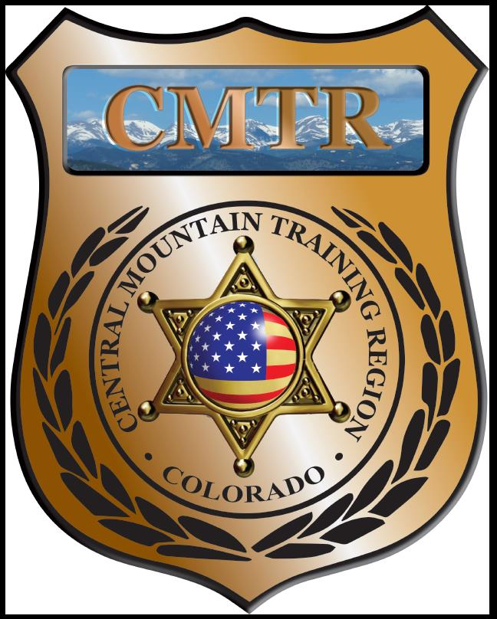

Meeting Agenda
April 4th, 2019
11:00am

Host:
Pikes Peak Community College
5675 S Academy Blvd
Colorado Springs, CO 80906
Meeting Agenda

CMTR Board Members
- President: Shelli Ellis Pueblo PD
- 1st Vice President: Shannon Byerly Custer County S.O.
- Secretary: Chris Adams Woodland Park PD
- Assistant Secretary: Russ Johnson Salida PD
- Voting Position: Janie Anderson Colorado Springs PD
- Voting Position: Chad Bauer Pikes Peak Community College
- Voting Position: Dave Clements Pueblo County SO
- Regional Training Coordinator: Jason Smith Pueblo PD

Welcome: New Faces and Guests
Treasurer’s Report: (Jason Smith)

Training
- Started with $135,334.48
- Patrol Rifle ($2,376.48)
- 7 classes remaining ($53,115.90)
- Balance $56,229.91

Equipment
- Started with $68,835
- Ammo ($5,899.53), Fuel ($205.35),Trailer lock & adapter ($40.98)
- Balance $12,573.61

Scholarships
- Started with $34,656.52
- 12 scholarships were approved in March ($5245), 6 Denied, 4 Tabled
- Remaining $8,891.61

Old Business
- Woodland Park Driving Simulator (>$2,500 one time fee or $8,000 1 yr contract)
- Ammunition request: Pueblo PD 1200 rounds of 9mm and 400 rds of 40 cal to send Detectives to the Regional B.A.T.T.L.E. (Beating Auto Theft Through LE) training in Florence. (Approved)
- Working on a FTO Development Class (CSOC) end of May beginning of June
- Grant Application March 15-April 15

New Business
- Suritec Wall System (provided with extra POST money) $56,424
- Update on Driving Simulator
- New Grant opened March 21st; Awarded $210,221 (T,E,S $182,801 and GM & PD $27,420)
- CIT Course (CSOC/Eric Fredrick) whole/split course

Training Request
Remaining Balance: $8,891.61

- From Agency: Park County SO
  - For (Officer): Josh Flowers
  - Class:Reid Techinque Interview and Interrogation
  - Date Requested: March 8th, 2019
  - Date(s): April 15-18, 2019
  - Location: Broomfield, CO
  - Class Cost: $575
  - Lodging: $0
  - Per Diem: $0
    - To: Action:
  - Related Cost: $0

Total Cost: $
Vote:
Ellis Y/N, Byerly Y/N, Adams Y/N, Johnson Y/N, Anderson Y/N, Bauer Y/N, Clements Y/N

- From Agency: Pueblo Police Department
  - For (Officer): Chad Garcia
  - Class: Intermediate Explosive Breachers Course
  - Date Requested: March 12th, 2019
  - Date(s): August 19-22, 2019
  - Location: Byhalia,MS
  - Class Cost: $1400
  - Lodging: $0
  - Per Diem: $0
    - To: Action:
  - Related Cost: $0

Total Cost: $
Vote:
Ellis Y/N, Byerly Y/N, Adams Y/N, Johnson Y/N, Anderson Y/N, Bauer Y/N, Clements Y/N

- From Agency: Pueblo Police Department
  - For (Officer): Erik Juno
  - Class: Explosive Handling & Breachers Course
  - Date Requested: March 12th, 2019
  - Date(s): July 7-13, 2019
  - Location: Tekamah, NE
  - Class Cost: $1450
  - Lodging: $0
  - Per Diem: $0
    - To: Action:
  - Related Cost: $0

Total Cost: $
Vote:
Ellis Y/N, Byerly Y/N, Adams Y/N, Johnson Y/N, Anderson Y/N, Bauer Y/N, Clements Y/N

- From Agency: Fountain Police Department
  - For (Officer): Alan Smith
  - Class: FBI Hostage Rescue
  - Date Requested: March 21, 2019
  - Date(s): May 6-8, 2019
  - Location: Brighton, CO
  - Class Cost: $175
  - Lodging: $0
  - Per Diem: $0
    - To: Action:
  - Related Cost: $0

Total Cost: $
Vote:
Ellis Y/N, Byerly Y/N, Adams Y/N, Johnson Y/N, Anderson Y/N, Bauer Y/N, Clements Y/N

- From Agency: Fountain Police Department
  - For (Officer): Isaiah Walter
  - Class: FBI Hostage Rescue
  - Date Requested: March 21, 2019
  - Date(s): May 6-8, 2019
  - Location: Brighton, CO
  - Class Cost: $175
  - Lodging: $0
  - Per Diem: $0
    - To: Action:
  - Related Cost: $0

Total Cost: $
Vote:
Ellis Y/N, Byerly Y/N, Adams Y/N, Johnson Y/N, Anderson Y/N, Bauer Y/N, Clements Y/N

- From Agency: Pueblo Police Department
  - For (Officer): Nikki Thomas
  - Class: RMDIAI Training Conference
  - Date Requested: March 25th, 2019
  - Date(s): May 15-17, 2019
  - Location: Denver,CO
  - Class Cost: $200
  - Lodging: $0
  - Per Diem: $0
    - To: Action:
  - Related Cost: $0

Total Cost: $
Vote:
Ellis Y/N, Byerly Y/N, Adams Y/N, Johnson Y/N, Anderson Y/N, Bauer Y/N, Clements Y/N

- From Agency: Pueblo Police Department
  - For (Officer): Stephen Perez
  - Class: RMDIAI Training Conference
  - Date Requested: March 25th, 2019
  - Date(s): May 15-17, 2019
  - Location: Denver,CO
  - Class Cost: $200
  - Lodging: $0
  - Per Diem: $0
    - To: Action:
  - Related Cost: $0

Total Cost: $
Vote:
Ellis Y/N, Byerly Y/N, Adams Y/N, Johnson Y/N, Anderson Y/N, Bauer Y/N, Clements Y/N

- From Agency: Teller County SO
  - For (Officer): Jaclyn Gaffney
  - Class: Rocky Mountain Death Investigation Conference
  - Date Requested: March 25th, 2019
  - Date(s): June 5-7, 2019
  - Location: Colo Springs, CO
  - Class Cost: $450
  - Lodging: $0
  - Per Diem: $0
    - To: Action:
  - Related Cost: $0

Total Cost: $
Vote:
Ellis Y/N, Byerly Y/N, Adams Y/N, Johnson Y/N, Anderson Y/N, Bauer Y/N, Clements Y/N

- From Agency: Pueblo Police Department
  - For (Officer): Lowell Griffiths
  - Class: Mexican Cartels and Gangs (Robert Almonte)
  - Date Requested: March 25, 2019
  - Date(s): April 9-12, 2019
  - Location: Westminster, CO
  - Class Cost: $395
  - Lodging: $0
  - Per Diem: $0
    - To: Action:
  - Related Cost: $0

Total Cost: $
Vote:
Ellis Y/N, Byerly Y/N, Adams Y/N, Johnson Y/N, Anderson Y/N, Bauer Y/N, Clements Y/N

- From Agency: Pueblo Police Department
  - For (Officer): Bryan Gonzales
  - Class: Mexican Cartels and Gangs (Robert Almonte)
  - Date Requested: March 25, 2019
  - Date(s): April 9-12, 2019
  - Location: Westminster, CO
  - Class Cost: $395
  - Lodging: $0
  - Per Diem: $0
    - To: Action:
  - Related Cost: $0

Total Cost: $
Vote:
Ellis Y/N, Byerly Y/N, Adams Y/N, Johnson Y/N, Anderson Y/N, Bauer Y/N, Clements Y/N

- From Agency: Pueblo Police Department
  - For (Officer): Joseph Cardona
  - Class: Reid Technique
  - Date Requested: March 27, 2019
  - Date(s): April 15-18, 2019
  - Location: Broomfield, CO
  - Class Cost: $575
  - Lodging: $0
  - Per Diem: $0
    - To: Action:
  - Related Cost: $0

Total Cost: $
Vote:
Ellis Y/N, Byerly Y/N, Adams Y/N, Johnson Y/N, Anderson Y/N, Bauer Y/N, Clements Y/N

- From Agency: Fremont County Sheriffs Office
  - For (Officer): Jeremy Green
  - Class: Force Science Certification Course
  - Date Requested: March 28th, 2019
  - Date(s): June 3-7, 2019
  - Location: Aurora, CO
  - Class Cost: $1650
  - Lodging: $0
  - Per Diem: $0
    - To: Action:
  - Related Cost: $0

Total Cost: $
Vote:
Ellis Y/N, Byerly Y/N, Adams Y/N, Johnson Y/N, Anderson Y/N, Bauer Y/N, Clements Y/N
Other Items to Discuss:
Notes:___________________________________________________________________________________________________________________________________________________________________________________________________________________________________
Central Mountain Training Region
Meeting Schedule 2018/19
(First Thursday of the Month) Start Time 11:00am

March 7th, 2019 Location/Host: August 1st, 2019 Location/Host:
Colorado Springs Police Department Woodland Park PD
725 N Murray Blvd 911 Tamarac Pkwy
Colorado Springs, CO 80915 Woodland Park, CO 80863
April 4th, 2019 Location/Host: September 5th, 2019Location/Host:
Pikes Peak Community College Salida PD
5675 S Academy Blvd 448 E 1st St
Colorado Springs, CO 80906 Salida, CO 81201
May 2nd, 2019 Location/Host: October 3rd, 2019 Location/Host:
Custer County Sheriff’s Office Canon City PD
702 Rosita Ave TBA
Westcliffe, CO 81252 Canon City, CO 81212
June 6th, 2019 Location/Host: November 7th, 2019 Location/Host:
Pueblo Police Department Colorado Springs Training Academy
200 S Main St 725 N Murray Blvd
Pueblo, CO 81003 Colorado Springs, CO 80915
July 11th, 2019 Location/Host: December 5th, 2019 Location/Host:
Pueblo County SO No Meeting
101 W 10th St
Pueblo, CO 81003

