Central Mountain Training Region

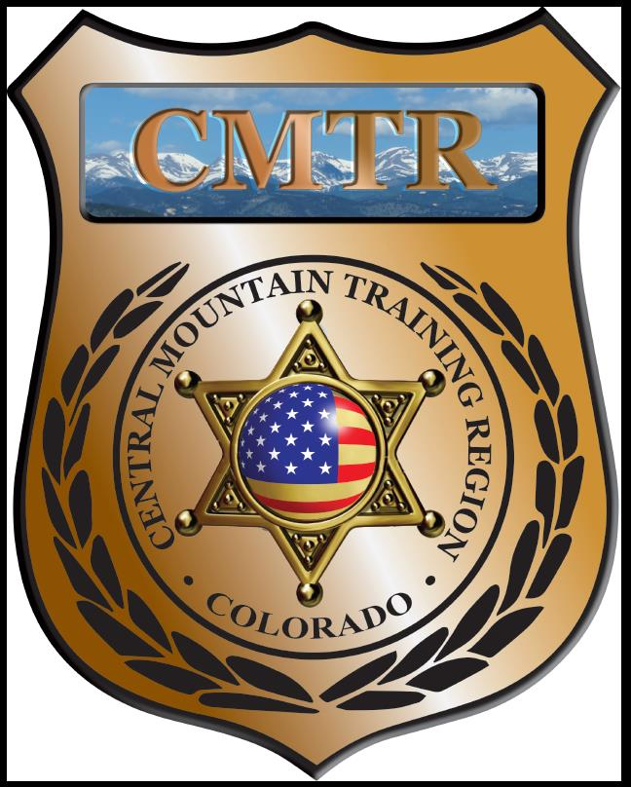

Meeting Agenda
May 2nd, 2019
11:00am

Host:
Custer County Sheriff’s Office
702 Rosita Ave
Westcliffe, CO 81252
Meeting Agenda

CMTR Board Members
- President: Shelli Ellis Pueblo PD
- 1st Vice President: Shannon Byerly Custer County S.O.
- Secretary: Chris Adams Woodland Park PD
- Assistant Secretary: Russ Johnson Salida PD
- Voting Position: Janie Anderson Colorado Springs PD
- Voting Position: Chad Bauer Pikes Peak Community College
- Voting Position: Dave Clements Pueblo County SO
- Regional Training Coordinator: Jason Smith Pueblo PD

Welcome: New Faces and Guests
Treasurer’s Report: (Jason Smith)

Training
- Started with $135,334.48
- Level III TA ($12,408.71), Driving Instructor ($), Handgun Instructor ($)
- 4 classes remaining ($32,790.90)
- Balance $56,229.91

Equipment
- Started with $68,835
- 18” Trailer ($6,450), Breaching Door ($3,454.23), Fuel ($284.30)
- Balance $2,582.49

Scholarships
- Started with $34,656.52
- 11 scholarships were approved in April ($4101.61), 2 Tabled
- Remaining $2,701.61

Old Business
- Suritec Wall System (provided with extra POST money) $56,424
- Update on Driving Simulator
- New Grant opened March 21st; Awarded $210,221 (T,E,S $182,801 and GM & PD $27,420)
- CIT Course (CSOC/Eric Fredrick) whole/split course

New Business
- FY20 Application has been submitted (22 classes)
- Bought trailer and breaching door on FY19

Training Request
Remaining Balance: $2,701.61

- From Agency: Salida PD
  - For (Officer): David Close
  - Class: School Based Threat & Volnerability Assessment
  - Date Requested:
  - Date(s): June 18-20, 2019
  - Location: Highlands Ranch
  - Class Cost: $250
  - Lodging: $0
  - Per Diem: $0
    - To: Action:
  - Related Cost: $0

Total Cost: $250
Vote:
Ellis Y/N, Byerly Y/N, Adams Y/N, Johnson Y/N, Anderson Y/N, Bauer Y/N, Clements Y/N

- From Agency: Pikes Peak Community College
  - For (Officer): Susan Barnes
  - Class: Constitutional Use of Force
  - Date Requested: April 15, 2019
  - Date(s): June 18, 2019
  - Location: Aurora, CO
  - Class Cost: $159
  - Lodging: $0
  - Per Diem: $0
    - To: Action:
  - Related Cost: $0

Total Cost: $159
Vote:
Ellis Y/N, Byerly Y/N, Adams Y/N, Johnson Y/N, Anderson Y/N, Bauer Y/N, Clements Y/N

- From Agency: Pueblo County SO
  - For (Officer): Steven Bryant
  - Class: SWAT Command Decision Making Leadership
  - Date Requested: April 17, 2019
  - Date(s): June 17-21, 2019
  - Location: Commerce City, CO
  - Class Cost: $710
  - Lodging: $0
  - Per Diem: $0
    - To: Action:
  - Related Cost: $0

Total Cost: $710
Vote:
Ellis Y/N, Byerly Y/N, Adams Y/N, Johnson Y/N, Anderson Y/N, Bauer Y/N, Clements Y/N

- From Agency: Pueblo Police Department
  - For (Officer): Ryan Masterson
  - Class:Advanced Response Police Officer (NTOA)
  - Date Requested: April 22, 2019
  - Date(s): June 24-28, 2019
  - Location: Siloam Springs, Arkansas
  - Class Cost: $780
  - Lodging: $0
  - Per Diem: $0
    - To: Action:
  - Related Cost: $0

Total Cost: $780
Vote:
Ellis Y/N, Byerly Y/N, Adams Y/N, Johnson Y/N, Anderson Y/N, Bauer Y/N, Clements Y/N

- From Agency: Pueblo Police Department
  - For (Officer): Brandon Beauvais
  - Class: Rocky Mountain Tactical Team Ass. Training
  - Date Requested: April 19, 2019
  - Date(s): May 5-8, 2019
  - Location: Broomfield, CO
  - Class Cost: $175
  - Lodging: $0
  - Per Diem: $0
    - To: Action:
  - Related Cost: $0

Total Cost: $175
Vote:
Ellis Y/N, Byerly Y/N, Adams Y/N, Johnson Y/N, Anderson Y/N, Bauer Y/N, Clements Y/N

- From Agency: Pueblo Police Department
  - For (Officer): Tommy DeCesaro
  - Class: Rocky Mountain Tactical Team Ass. Training
  - Date Requested: April 19, 2019
  - Date(s): May 5-8, 2019
  - Location: Broomfield, CO
  - Class Cost: $175
  - Lodging: $0
  - Per Diem: $0
    - To: Action:
  - Related Cost: $0

Total Cost: $175
Vote:
Ellis Y/N, Byerly Y/N, Adams Y/N, Johnson Y/N, Anderson Y/N, Bauer Y/N, Clements Y/N

- From Agency: Park County SO
  - For (Officer): Joshua Flowers
  - Class: Basic Criminal Investigator and New Detective Training
  - Date Requested: April 25, 2019
  - Date(s): May 13-17, 2019
  - Location: Denver, CO
  - Class Cost: $525
  - Lodging: $0
  - Per Diem: $0
    - To: Action:
  - Related Cost: $0

Total Cost: $525
Vote:
Ellis Y/N, Byerly Y/N, Adams Y/N, Johnson Y/N, Anderson Y/N, Bauer Y/N, Clements Y/N

- From Agency: Park County SO
  - For (Officer): Greg Kimsey
  - Class: Basic Criminal Investigator and New Detective Training
  - Date Requested: April 25, 2019
  - Date(s): May 13-17, 2019
  - Location: Denver, CO
  - Class Cost: $525
  - Lodging: $0
  - Per Diem: $0
    - To: Action:
  - Related Cost: $0

Total Cost: $525
Vote:
Ellis Y/N, Byerly Y/N, Adams Y/N, Johnson Y/N, Anderson Y/N, Bauer Y/N, Clements Y/N

- From Agency:
  - For (Officer):
  - Class:
  - Date Requested:
  - Date(s):
  - Location:
  - Class Cost: $0
  - Lodging: $0
  - Per Diem: $0
    - To: Action:
  - Related Cost: $0

Total Cost: $
Vote:
Ellis Y/N, Byerly Y/N, Adams Y/N, Johnson Y/N, Anderson Y/N, Bauer Y/N, Clements Y/N

Other Items to Discuss:
Notes:___________________________________________________________________________________________________________________________________________________________________________________________________________________________________

Central Mountain Training Region
Meeting Schedule 2018/19
(First Thursday of the Month) Start Time 11:00am
September 5th, 2019 Location/Host:
Salida Police Department
448 E 1st St
Salida, CO 81201
May 2nd, 2019 Location/Host:
Custer County Sheriff’s Office
702 Rosita Ave
Westcliffe, CO 81252

October 3rd, 2019 Location/Host:
Canon City Police Department
TBA
Canon City, CO 81212
June 6th, 2019 Location/Host:
Pueblo Police Department
200 S Main St
Pueblo, CO 81003

November 7th, 2019 Location/Host:
Colorado Springs Training Academy
725 N Murray Blvd
Colorado Springs, CO 80915
July 6th, 2019 Location/Host:
Pueblo County SO
101 W 10th St
Pueblo, CO 81003

December 5th, 2019 Location/Host:
No Meeting

August 1st, 2019 Location/Host:
Woodland Park PD
911 Tamarac Pkwy
Woodland Park, CO 80863

