Central Mountain Training Region

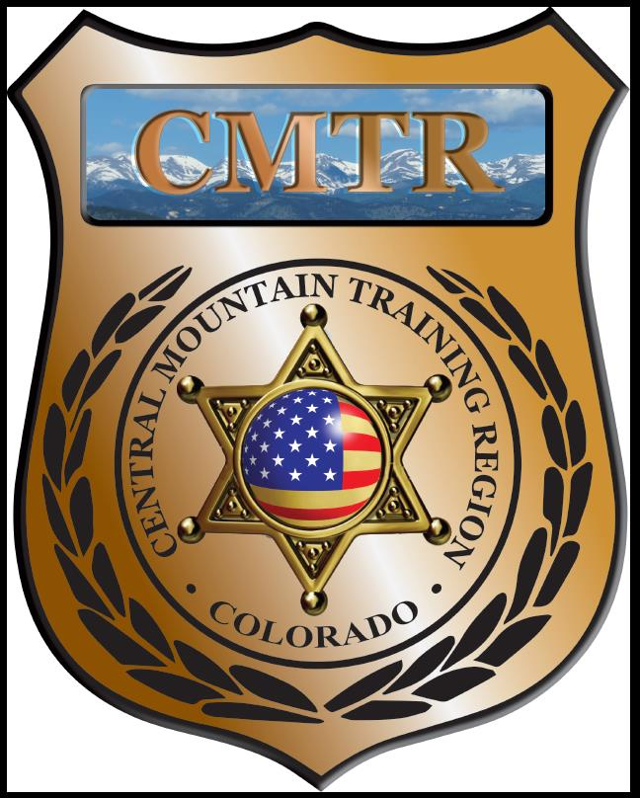

Meeting Agenda
June 6th, 2019
11:00am

Host:
Pueblo Police Department
200 S Main St
Pueblo, CO 81003
Meeting Agenda

CMTR Board Members
- President: Shelli Ellis Pueblo PD
- 1st Vice President: Shannon Byerly Custer County S.O.
- Secretary: Chris Adams Woodland Park PD
- Assistant Secretary: Russ Johnson Salida PD
- Voting Position: Bruce Briscoe Fremont County SO
- Voting Position: Chad Bauer Pikes Peak Community College
- Voting Position: Dave Clements Pueblo County SO
- Regional Training Coordinator: Jason Smith Pueblo PD

Welcome: New Faces and Guests
Treasurer’s Report: (Jason Smith)

Training
- Started with $135,334.48
- Shotgun Instructor ($13,908.80), AR15 Armerors ($7112.06), Train the Trainer($), Spanish for LE($)
- Balance $16,139.20

Equipment
- Started with $68,835
- Bought 9mm ($1352), 18” Trailer ($6450), Breaching Door ($3454.23), Trailer material ($176.98), Fuel ($326.79), bedliner ($550), steel target ($273.99)
- Balance $744.29

Scholarships
- Started with $34,656.52
- 10 scholarships were approved in May ($4349)
- Moved $2032.39 from Training to cover scholarship requests
- Remaining $1390

Total Remaining $5,513.71

Old Business
- FY20 Application has been submitted (22 classes)
- Bought trailer and breaching door on FY19
- Voted to have Bruce Briscoe take over Janie Anderson’s spot on the Board as a Voting Member.

New Business
- Survitec Wall System was ordered
- Haven’t heard back from POST yet on FY20.
- Interest in a 2-day MRAP class in Florence (free, may pay for snacks)
- Febuary-June meeting locations

Training Request
Remaining Balance: $1390

- From Agency: Fountian PD
  - For (Officer): Mark Cristiani
  - Class: Rocky Mountain Command College
  - Date Requested: 2/26/19
  - Date(s): July 15-19 2019
  - Location: Metro State Univ. Denver
  - Class Cost: $300
  - Lodging: $0
  - Per Diem: $0
    - To: Action:
  - Related Cost: $0

Total Cost: $300
Vote:
Ellis Y/N, Byerly Y/N, Adams Y/N, Johnson Y/N, Anderson Y/N, Bauer Y/N, Clements Y/N

- From Agency: Fountian PD
  - For (Officer): Matt Racine
  - Class: Rocky Mountain Command College
  - Date Requested: 2/26/19
  - Date(s): July 15-19 2019
  - Location: Metro State Univ. Denver
  - Class Cost: $300
  - Lodging: $0
  - Per Diem: $0
    - To: Action:
  - Related Cost: $0

Total Cost: $300
Vote:
Ellis Y/N, Byerly Y/N, Adams Y/N, Johnson Y/N, Anderson Y/N, Bauer Y/N, Clements Y/N

- From Agency: Fountian PD
  - For (Officer): Danica McGee
  - Class: Rocky Mountain Command College
  - Date Requested: 2/26/19
  - Date(s): July 15-19 2019
  - Location: Metro State Univ. Denver
  - Class Cost: $300
  - Lodging: $0
  - Per Diem: $0
    - To: Action:
  - Related Cost: $0

Total Cost: $300
Vote:
Ellis Y/N, Byerly Y/N, Adams Y/N, Johnson Y/N, Anderson Y/N, Bauer Y/N, Clements Y/N

- From Agency: Pueblo Police Department
  - For (Officer): Chad Garcia
  - Class: Intermediate Explosive Breachers Course
  - Date Requested: March 12th, 2019
  - Date(s): August 19-22, 2019
  - Location: Byhalia,MS
  - Class Cost: $1400
  - Lodging: $0
  - Per Diem: $0
    - To: Action:
  - Related Cost: $0

Total Cost: $1400
Vote:
Ellis Y/N, Byerly Y/N, Adams Y/N, Johnson Y/N, Anderson Y/N, Bauer Y/N, Clements Y/N

- From Agency: Pueblo Police Department
  - For (Officer): Erik Juno
  - Class: Explosive Handling & Breachers Course
  - Date Requested: March 12th, 2019
  - Date(s): July 7-13, 2019
  - Location: Tekamah, NE
  - Class Cost: $1450
  - Lodging: $0
  - Per Diem: $0
    - To: Action:
  - Related Cost: $0

Total Cost: $1450
Vote:
Ellis Y/N, Byerly Y/N, Adams Y/N, Johnson Y/N, Anderson Y/N, Bauer Y/N, Clements Y/N

- From Agency: Salida Police Department
  - For (Officer): Lance Cliff
  - Class: Krav Maga Instructor Recert
  - Date Requested:
  - Date(s): August 12-16, 2019
  - Location: Broomfield, CO
  - Class Cost: $825
  - Lodging: $0
  - Per Diem: $0
    - To: Action:
  - Related Cost: $0

Total Cost: $825
Vote:
Ellis Y/N, Byerly Y/N, Adams Y/N, Johnson Y/N, Anderson Y/N, Bauer Y/N, Clements Y/N

- From Agency: Custer County SO
  - For (Officer): Eric Dunston
  - Class: Vehicle CQB
  - Date Requested: 2/19/19
  - Date(s): November 4-8, 2019
  - Location: Erie, CO
  - Class Cost: $960
  - Lodging: $0
  - Per Diem: $0
    - To: Action:
  - Related Cost: $0

Total Cost: $960
Vote:
Ellis Y/N, Byerly Y/N, Adams Y/N, Johnson Y/N, Anderson Y/N, Bauer Y/N, Clements Y/N

- From Agency: Teller County SO
  - For (Officer): Sven Bonnelycke
  - Class: CLERIA Conference
  - Date Requested: June 4, 2019
  - Date(s): July 31-August 2, 2019
  - Location: Highlands Ranch, CO
  - Class Cost: $375
  - Lodging: $0
  - Per Diem: $0
    - To: Action:
  - Related Cost: $0

Total Cost: $375
Vote:
Ellis Y/N, Byerly Y/N, Adams Y/N, Johnson Y/N, Anderson Y/N, Bauer Y/N, Clements Y/N

Other Items to Discuss:
Notes:___________________________________________________________________________________________________________________________________________________________________________________________________________________________________

Central Mountain Training Region
Meeting Schedule 2018/19
(First Thursday of the Month) Start Time 11:00am
November 7th, 2019 Location/Host:
Colorado Springs Training Academy
725 N Murray Blvd
Colorado Springs, CO 80915
July 6th, 2019 Location/Host:
Pueblo County SO
101 W 10th St
Pueblo, CO 81003

December 5th, 2019 Location/Host:
No Meeting

August 1st, 2019 Location/Host:
Woodland Park PD
911 Tamarac Pkwy
Woodland Park, CO 80863

January 2nd, 2019 Location/Host:
Pueblo Police Department
200 S Main St
Pueblo, CO 81003
September 5th, 2019 Location/Host:
Salida Police Department
448 E 1st St
Salida, CO 81201

October 3rd, 2019 Location/Host:
Canon City Police Department
TBA
Canon City, CO 81212

