Central Mountain Training Region

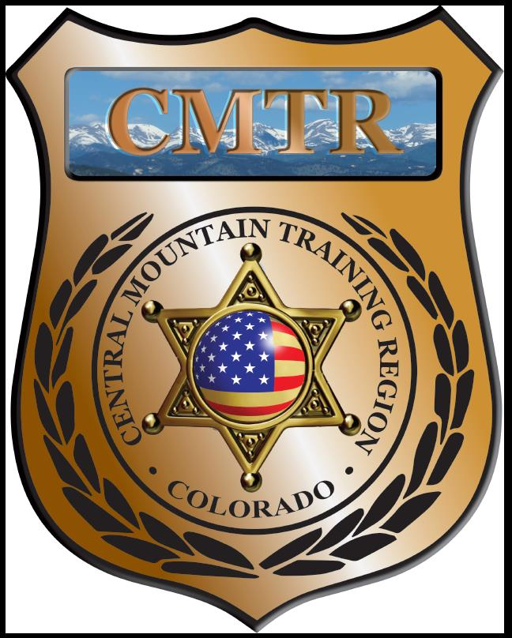

Meeting Agenda
July 11th, 2019
11:00am

Host:
Pueblo County SO
101 W 10th St
Pueblo, CO 81003
Meeting Agenda

CMTR Board Members
- President: Shelli Ellis Pueblo PD
- 1st Vice President: Shannon Byerly Custer County S.O.
- Secretary: Chris Adams Woodland Park PD
- Assistant Secretary: Russ Johnson Salida PD
- Voting Position: Bruce Briscoe Fremont County SO
- Voting Position: Chad Bauer Pikes Peak Community College
- Voting Position: Dave Clements Pueblo County SO
- Regional Training Coordinator: Jason Smith Pueblo PD

Welcome: New Faces and Guests
Treasurer’s Report: (Jason Smith)

Training
- Started with $131,810.00
- Balance $131,810.00

Equipment
- Started with $20,991.00
- Balance $20,991.00

Scholarships
- Started with $30,000.00
- 7 scholarships were approved in June ($5085)
- Remaining $24,915

Old Business
- Survitec Wall System was ordered
- Haven’t heard back from POST yet on FY20.
- Interest in a 2-day MRAP class in Florence (free, may pay for snacks)
- Febuary-June meeting locations

New Business
- Closed out FY19 budget. 282 (113 Urban, 169 Rural) Officers went through training, 65 Scholarships given out and total of 10,625 training hours provided with both. Spent 99.56% of budget or $329,620
- FY20 Update
- POST Guideline change; Section 13.1 Class Announcement/Enrollment Management
-Grantee agrees to notify POST at least 60 days in advance of the class date. The class will be available for enrollment the first 30 days to LE within the training region, enrollment will be available day 30-45 to LE outside the training region, and at day 15 enrollment for the class will close. Enrollment past the close date can occur with prior POST approval. The Grantee agrees to limit enrollment for training, including the host agency, to four (4) seats, or 20% of the class size (whichever is greater) for each agency within the Region, until two (2) weeks prior to the start of training. The exception to this is when a course is held at a venue that can accommodate a large number of attendees or there are plenty of open seats.

- Review of Sections 7.1 Refreshments/Snacks, 8.1 Scholarships and 8.2 Conference Attendance.
- Posted Basic SWAT School (July 22-26), New Detective (August 12-13), Driving Instructor (August 19-23), Armor Yourself (August 29), Instructor Methodology (Sept 9-13), The Unspoken Dialogue (Sept 19-20) and Adv Handgun Instructor (August 26-27) classes

Training Request
Remaining Balance: $24,915

- From Agency: Cripple Creek
  - For (Officer): Jacob Lucero
  - Class: CASRO Conference
  - Date Requested:
  - Date(s): July 16-18, 2019
  - Location: Cripple Creek
  - Class Cost: $400
  - Lodging: $0
  - Per Diem: $0
    - To: Action:
  - Related Cost: $0
Approved

Total Cost: $400
Vote:
Ellis Y/N, Byerly Y/N, Adams Y/N, Johnson Y/N, Anderson Y/N, Bauer Y/N, Clements Y/N

- From Agency: Pueblo PD
  - For (Officer): Roger Schneider
  - Class: Friction Ridge Examination
  - Date Requested: 6/20/19
  - Date(s): August 19-23, 2019
  - Location: Jefferson County Crime Lab
  - Class Cost: $600
  - Lodging: $0
  - Per Diem: $0
    - To: Action:
  - Related Cost: $0
Approved

Total Cost: $600
Vote:
Ellis Y/N, Byerly Y/N, Adams Y/N, Johnson Y/N, Anderson Y/N, Bauer Y/N, Clements Y/N

- From Agency: Pueblo Police Department
  - For (Officer): Ronald Gravatt
  - Class: Advanced Practical Homicide Investigation
  - Date Requested: 6/17/19
  - Date(s): November 18-22, 2019
  - Location: Grapevine, TX
  - Class Cost: $800
  - Lodging: $0
  - Per Diem: $0
    - To: Action:
  - Related Cost: $0
More information

Total Cost: $800
Vote:
Ellis Y/N, Byerly Y/N, Adams Y/N, Johnson Y/N, Anderson Y/N, Bauer Y/N, Clements Y/N

- From Agency: Canon City PD
  - For (Officer): Timothy Bell
  - Class: Developing Scenario-Based Training
  - Date Requested: 6/24/19
  - Date(s): August 27-28, 2019
  - Location: Pueblo
  - Class Cost: $299
  - Lodging: $0
  - Per Diem: $0
    - To: Action:
  - Related Cost: $0
Approved

Total Cost: $299
Vote:
Ellis Y/N, Byerly Y/N, Adams Y/N, Johnson Y/N, Anderson Y/N, Bauer Y/N, Clements Y/N

- From Agency: Canon City PD
  - For (Officer): Timothy Bell
  - Class: 48 Tenants of Officer Survival
  - Date Requested: 06/24/19
  - Date(s): August 26, 2019
  - Location: Pueblo
  - Class Cost: $125
  - Lodging: $0
  - Per Diem: $0
    - To: Action:
  - Related Cost: $0
Approved

Total Cost: $125
Vote:
Ellis Y/N, Byerly Y/N, Adams Y/N, Johnson Y/N, Anderson Y/N, Bauer Y/N, Clements Y/N

- From Agency: Pueblo PD
  - For (Officer): David Woods
  - Class: BWC, Civilian Recordings and Social Media
  - Date Requested: 6/28/19
  - Date(s): August 27, 2019
  - Location: Denver Sheriff’s Office
  - Class Cost: $195
  - Lodging: $0
  - Per Diem: $0
    - To: Action:
  - Related Cost: $0
Approved

Total Cost: $195
Vote:
Ellis Y/N, Byerly Y/N, Adams Y/N, Johnson Y/N, Anderson Y/N, Bauer Y/N, Clements Y/N

- From Agency: Custer County SO
  - For (Officer): Nathan Koury
  - Class: Vehicle CQB
  - Date Requested: 07/11/19
  - Date(s): November 4-8, 2019
  - Location: Eric, CO
  - Class Cost: $960
  - Lodging: $0
  - Per Diem: $0
    - To: Action:
  - Related Cost: $0
Approved

Total Cost: $960
Vote:
Ellis Y/N, Byerly Y/N, Adams Y/N, Johnson Y/N, Anderson Y/N, Bauer Y/N, Clements Y/N

- From Agency: Fountain PD
  - For (Officer): Sheyna Marshall
  - Class: Child Forensic Interview Clinics
  - Date Requested: 07/08/19
  - Date(s): August 26-30, 2019
  - Location: Seatle, WA
  - Class Cost: $1299
  - Lodging: $0
  - Per Diem: $0
    - To: Action:
  - Related Cost: $0
More information

Total Cost: $1299
Vote:
Ellis Y/N, Byerly Y/N, Adams Y/N, Johnson Y/N, Anderson Y/N, Bauer Y/N, Clements Y/N

- From Agency: Pikes Peak CC
  - For (Officer): Moses Cho
  - Class: Advanced Search and Seizure
  - Date Requested: 07/11/19
  - Date(s): July 16, 2019
  - Location: Littleton, CO
  - Class Cost: $149
  - Lodging: $0
  - Per Diem: $0
    - To: Action:
  - Related Cost: $0
Approved

Total Cost: $149
Vote:
Ellis Y/N, Byerly Y/N, Adams Y/N, Johnson Y/N, Anderson Y/N, Bauer Y/N, Clements Y/N

Other Items to Discuss:
Notes:___________________________________________________________________________________________________________________________________________________________________________________________________________________________________

Central Mountain Training Region
Meeting Schedule FY20
(First Thursday of the Month) Start Time 11:00am
September 5th, 2019 Location/Host:
Salida Police Department
448 E 1st St
Salida, CO 81201
August 1st, 2019 Location/Host:
Woodland Park PD
911 Tamarac Pkwy
Woodland Park, CO 80863

November 7th, 2019 Location/Host:
Colorado Springs Training Academy
725 N Murray Blvd
Colorado Springs, CO 80915
October 3rd, 2019 Location/Host:
Canon City Police Department
TBA
Canon City, CO 81212

January 2nd, 2020 Location/Host:
Pueblo Police Department
200 S Main St
Pueblo, CO 81003
December 5th, 2019 Location/Host:
No Meeting

March 5th, 2020 Location/Host:
Woodland Park PD
911 Tamarac Pkwy
Woodland Park, CO 80863
February 6th, 2020 Location/Host:
Pueblo County SO
101 W 10th St
Pueblo, CO 81003

May 7th, 2020 Location/Host:
Manitou Springs PD
606 Manitou Ave
Manitou Springs, CO 80829
April 2nd, 2020 Location/Host:
Pikes Peak Community College
5675 Academy Blvd
Colorado Springs, CO 80906

