Central Mountain Training Region

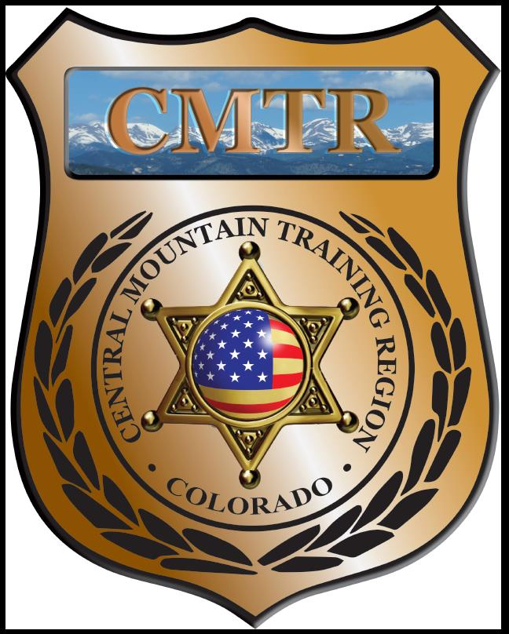

Meeting Agenda
August 1st, 2019
11:00am

Host:
Woodland Park PD
911 Tamarac Pkwy
Woodland Park, CO 80863
Meeting Agenda

CMTR Board Members
- President: Shelli Ellis Pueblo PD
- 1st Vice President: Shannon Byerly Custer County S.O.
- Secretary: Chris Adams Woodland Park PD
- Assistant Secretary: Russ Johnson Salida PD
- Voting Position: Bruce Briscoe Fremont County SO
- Voting Position: Chad Bauer Pikes Peak Community College
- Voting Position: Dave Clements Pueblo County SO
- Regional Training Coordinator: Jason Smith Pueblo PD

Welcome: New Faces and Guests
Treasurer’s Report: (Jason Smith)

Training
- Started with $131,810.00
- Balance $131,810.00

Equipment
- Started with $20,991.00
- Balance $20,991.00

Scholarships
- Started with $30,000.00
- 9 scholarships were approved in July ($4178)
- Remaining $20,737.00

Old Business
- Closed out FY19 budget. 282 (113 Urban, 169 Rural) Officers went through training, 65 Scholarships given out and total of 10,625 training hours provided with both. Spent 99.56% of budget or $329,620
- FY20 Update
- POST Guideline change; Section 13.1 Class Announcement/Enrollment Management
- Review of Sections 7.1 Refreshments/Snacks, 8.1 Scholarships and 8.2 Conference Attendance.
- Posted Basic SWAT School (July 22-26), New Detective (August 12-13), Driving Instructor (August 19-23), Armor Yourself (August 29), Instructor Methodology (Sept 9-13), The Unspoken Dialogue (Sept 19-20) and Adv Handgun Instructor (August 26-27) classes

New Business
- Resignation of Chris Adams from Secretary. Vote for his replacement.
- POST meeting August 13th 9-4pm (Informational Meeting)
- Town Hall meeting with POST August 14th 1-3pm Pueblo PD

Training Request
Remaining Balance: $24,915

- From Agency: Canon City
  - For (Officer): John Sabatino
  - Class: Police Motorcycle Operator Training
  - Date Requested:
  - Date(s): August 12-23, 2019
  - Location: Douglas County
  - Class Cost: $1595
  - Lodging: $0
  - Per Diem: $0
    - To: Action:
  - Related Cost: $0

Total Cost: $1595
Vote:
Ellis Y/N, Byerly Y/N, Adams Y/N, Johnson Y/N, Anderson Y/N, Bauer Y/N, Clements Y/N

- From Agency: Pueblo PD
  - For (Officer): Zach Ballas
  - Class: Background Investigations for Police Applicants
  - Date Requested: 07/12/19
  - Date(s): September 5-6, 2019
  - Location: Commerce City, CO
  - Class Cost: $350
  - Lodging: $0
  - Per Diem: $0
    - To: Action:
  - Related Cost: $0

Total Cost: $350
Vote:
Ellis Y/N, Byerly Y/N, Adams Y/N, Johnson Y/N, Anderson Y/N, Bauer Y/N, Clements Y/N

- From Agency: Pueblo PD
  - For (Officer): Melissa Jacober
  - Class: Background Investigations for Police Applicants
  - Date Requested: 07/12/19
  - Date(s): September 5-6, 2019
  - Location: Commerce City, CO
  - Class Cost: $350
  - Lodging: $0
  - Per Diem: $0
    - To: Action:
  - Related Cost: $0

Total Cost: $350
Vote:
Ellis Y/N, Byerly Y/N, Adams Y/N, Johnson Y/N, Anderson Y/N, Bauer Y/N, Clements Y/N

- From Agency: Pueblo PD
  - For (Officer): Daniel Anderson
  - Class: Sex Trafficking and Prostitution in mid size cities
  - Date Requested: 07/22/19
  - Date(s): September 24-27, 2019
  - Location: Fort Collins, CO
  - Class Cost: $260.34
  - Lodging: $0
  - Per Diem: $0
    - To: Action:
  - Related Cost: $0

Total Cost: $260.34
Vote:
Ellis Y/N, Byerly Y/N, Adams Y/N, Johnson Y/N, Anderson Y/N, Bauer Y/N, Clements Y/N

- From Agency:
  - For (Officer):
  - Class:
  - Date Requested:
  - Date(s):
  - Location:
  - Class Cost: $0
  - Lodging: $0
  - Per Diem: $0
    - To: Action:
  - Related Cost: $0

Total Cost: $
Vote:
Ellis Y/N, Byerly Y/N, Adams Y/N, Johnson Y/N, Anderson Y/N, Bauer Y/N, Clements Y/N

Other Items to Discuss:
Notes:___________________________________________________________________________________________________________________________________________________________________________________________________________________________________

Central Mountain Training Region
Meeting Schedule FY20
(First Thursday of the Month) Start Time 11:00am
September 5th, 2019 Location/Host:
Salida Police Department
448 E 1st St
Salida, CO 81201

November 7th, 2019 Location/Host:
Colorado Springs Training Academy
725 N Murray Blvd
Colorado Springs, CO 80915
October 3rd, 2019 Location/Host:
Canon City Police Department
TBA
Canon City, CO 81212

January 2nd, 2020 Location/Host:
Pueblo Police Department
200 S Main St
Pueblo, CO 81003
December 5th, 2019 Location/Host:
No Meeting

March 5th, 2020 Location/Host:
Woodland Park PD
911 Tamarac Pkwy
Woodland Park, CO 80863
February 6th, 2020 Location/Host:
Pueblo County SO
101 W 10th St
Pueblo, CO 81003

May 7th, 2020 Location/Host:
Manitou Springs PD
606 Manitou Ave
Manitou Springs, CO 80829
April 2nd, 2020 Location/Host:
Pikes Peak Community College
5675 Academy Blvd
Colorado Springs, CO 80906

