Central Mountain Training Region

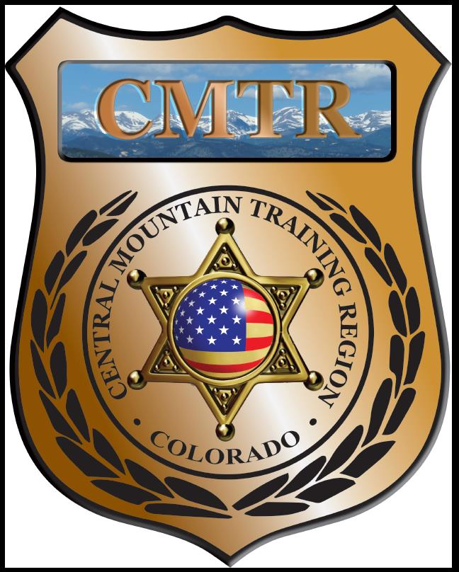

Meeting Agenda
September 5th, 2019
11:00am

Host:
Salida Police Department
220 W Sackett Ave
Salida, CO 81201
Meeting Agenda

CMTR Board Members
- President: Shelli Ellis Pueblo PD
- 1st Vice President: Shannon Byerly Custer County S.O.
- Secretary: Ryan Holdsworth Woodland Park PD
- Assistant Secretary: Russ Johnson Salida PD
- Voting Position: Bruce Briscoe Fremont County SO
- Voting Position: Chad Bauer Pikes Peak Community College
- Voting Position: Dave Clements Pueblo County SO
- Regional Training Coordinator: Jason Smith Pueblo PD

Welcome: New Faces and Guests
Treasurer’s Report: (Jason Smith)

Training
- Started with $131,810.00
- Basic SWAT School ($1,949.45), New Detective ($10,199.75), Armor Yourself ($7,578.77), Driving Instructor ($3143.90)
- Balance $108,638.13

Equipment
- Started with $20,991.00
- Fuel $200.25
- Balance $20,790.75

Scholarships
- Started with $30,000.00
- 8 scholarships were approved in August ($3,450.34)
- Total spent $14,613.34
- Remaining $15,760.66

Old Business
- Resignation of Chris Adams from Secretary. Vote for his replacement.
- POST meeting August 13th 9-4pm (Informational Meeting)
- Town Hall meeting with POST August 14th 1-3pm Pueblo PD

New Business
- Go over POST meeting (August 13th)
- DU Public Safety Leadership Program
- Level II Instructor Methodology class
- Patrol Officer-Tactical Development Course
- Equipment-Motorola radio XTS1500 (Park County SO)
- Equipment Policy?
Training Request
Remaining Balance: $15,760.66

- From Agency: Canon City PD
  - For (Officer): Timothy Bell
  - Class: Understanding Mexican Cartels
  - Date Requested: 08/0519
  - Date(s): August 6-9, 2019
  - Location: Colorado Springs, CO
  - Class Cost: $300
  - Lodging: $0
  - Per Diem: $0
    - To: Action:
  - Related Cost: $0

Total Cost: $300
Vote:
Ellis Y/N, Byerly Y/N, Adams Y/N, Johnson Y/N, Anderson Y/N, Bauer Y/N, Clements Y/N

- From Agency: Pueblo Police Department
  - For (Officer): Chris Alarid
  - Class: Needle in the Haystack: The Unsolvable Hit and Run
  - Date Requested: 08/09/19
  - Date(s): Webiner
  - Location: Pueblo PD
  - Class Cost: $85
  - Lodging: $0
  - Per Diem: $0
    - To: Action:
  - Related Cost: $0

Total Cost: $85
Vote:
Ellis Y/N, Byerly Y/N, Adams Y/N, Johnson Y/N, Anderson Y/N, Bauer Y/N, Clements Y/N

- From Agency: 10th Judicial District Attorney’s Office
  - For (Officer): Paul “Jake” Villegas
  - Class: Use of Force, Deadly Force & Officer Involved Shootings
  - Date Requested: 08/01/19
  - Date(s): December 9-12, 2019
  - Location: Las Vegas, NV
  - Class Cost: $525
  - Lodging: $610
  - Per Diem: $172
    - To: Action:
  - Related Cost: Flights $208, Parking $46

Total Cost: $1561
Vote:
Ellis Y/N, Byerly Y/N, Adams Y/N, Johnson Y/N, Anderson Y/N, Bauer Y/N, Clements Y/N

- From Agency: Pueblo PD
  - For (Officer): Brandon Colbert
  - Class: Arson Investigators 11th Annuel Conference
  - Date Requested: 08/14/19
  - Date(s): October 23-25, 2019
  - Location: Vail, CO
  - Class Cost: $350
  - Lodging: $0
  - Per Diem: $0
    - To: Action:
  - Related Cost: $0

Total Cost: $350
Vote:
Ellis Y/N, Byerly Y/N, Adams Y/N, Johnson Y/N, Anderson Y/N, Bauer Y/N, Clements Y/N

- From Agency: Pueblo PD
  - For (Officer): Jason Smith
  - Class: Bolt Action Sniper Rifle Armorer School
  - Date Requested: 08/28/19
  - Date(s): December 9, 2019
  - Location: Castle Rock, CO
  - Class Cost: $250
  - Lodging: $0
  - Per Diem: $0
    - To: Action:
  - Related Cost: $0

Total Cost: $250
Vote:
Ellis Y/N, Byerly Y/N, Adams Y/N, Johnson Y/N, Anderson Y/N, Bauer Y/N, Clements Y/N

Other Items to Discuss:
Notes:___________________________________________________________________________________________________________________________________________________________________________________________________________________________________

Central Mountain Training Region
Meeting Schedule FY20
(First Thursday of the Month) Start Time 11:00am
November 7th, 2019 Location/Host:
Colorado Springs Training Academy
725 N Murray Blvd
Colorado Springs, CO 80915
October 3rd, 2019 Location/Host:
Canon City Police Department
TBA
Canon City, CO 81212

January 2nd, 2020 Location/Host:
Pueblo Police Department
200 S Main St
Pueblo, CO 81003
December 5th, 2019 Location/Host:
No Meeting

March 5th, 2020 Location/Host:
Woodland Park PD
911 Tamarac Pkwy
Woodland Park, CO 80863
February 6th, 2020 Location/Host:
Pueblo County SO
101 W 10th St
Pueblo, CO 81003

May 7th, 2020 Location/Host:
Manitou Springs PD
606 Manitou Ave
Manitou Springs, CO 80829
April 2nd, 2020 Location/Host:
Pikes Peak Community College
5675 Academy Blvd
Colorado Springs, CO 80906

