Central Mountain Training Region

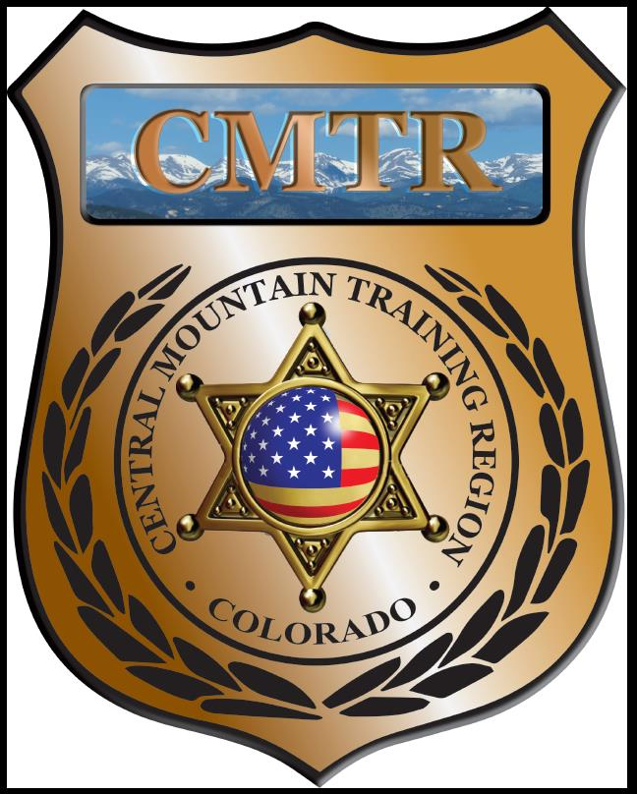

Meeting Agenda
October 3rd, 2019
11:00am

Host:
Canon City Police Department
128 Main St
Canon City, CO 81212
Meeting Agenda

CMTR Board Members
- President: Shelli Ellis Pueblo PD
- 1st Vice President: Shannon Byerly Custer County S.O.
- Secretary: Ryan Holzwarth Woodland Park PD
- Assistant Secretary: Russ Johnson Salida PD
- Voting Position: Bruce Briscoe Fremont County SO
- Voting Position: Chad Bauer Pikes Peak Community College
- Voting Position: Dave Clements Pueblo County SO
- Regional Training Coordinator: Jason Smith Pueblo PD

Welcome: New Faces and Guests
Treasurer’s Report: (Jason Smith)

Training
- Started with $131,810.00
- Instructor Methodology ($5,332.28)
- Balance $103,567.29

Equipment
- Started with $20,991.00
- Fuel $196.75
- Balance $20,594.00

Scholarships
- Started with $30,000.00
- 5 scholarships were approved in September ($1,510)
- Total spent $14,399.34
- Remaining $15,600.66

Old Business
- Go over POST meeting (August 13th)
- DU Public Safety Leadership Program
- Level II Instructor Methodology class
- Patrol Officer-Tactical Development Course
- Equipment-Motorola radio XTS1500 (Park County SO)
- Equipment Policy?

New Business
- Public Safety Leadership Development class
- FBI Command Leadership class (lower enrollment)
- Training Needs Analysis (Training,Leadership, and Change Management, LLC)
- Upcoming training classes and registration.

Training Request
Remaining Balance: $15,600.66

- From Agency: Pueblo Community College PD
  - For (Officer): William Brown
  - Class: Digital Threat
  - Date Requested: 09/10/19
  - Date(s): September 25th, 2019
  - Location: Cenntennial, CO
  - Class Cost: $120
  - Lodging: $0
  - Per Diem: $0
    - To: Action:
  - Related Cost: $0

Total Cost: $120
Vote:
Ellis Y/N, Byerly Y/N, Holzwarth Y/N, Johnson Y/N, Briscoe Y/N, Bauer Y/N, Clements Y/N

- From Agency: Pueblo Community College PD
  - For (Officer): William Brown
  - Class: Digital Threat
  - Date Requested: 09/10/19
  - Date(s): September 25th, 2019
  - Location: Cenntennial, CO
  - Class Cost: $120
  - Lodging: $0
  - Per Diem: $0
    - To: Action:
  - Related Cost: $0

Total Cost: $120
Vote:
Ellis Y/N, Byerly Y/N, Holzwarth Y/N, Johnson Y/N, Briscoe Y/N, Bauer Y/N, Clements Y/N

- From Agency: 10th Judicial District Attorney’s Office
  - For (Officer): Christine Hansel
  - Class: PATC Human Trafficking Investigations
  - Date Requested: 09/19/19
  - Date(s): October 15-17th, 2019
  - Location: Moline, IL
  - Class Cost: $325
  - Lodging: $0
  - Per Diem: $0
    - To: Action:
  - Related Cost:

Total Cost: $325
Vote:
Ellis Y/N, Byerly Y/N, Holzwarth Y/N, Johnson Y/N, Briscoe Y/N, Bauer Y/N, Clements Y/N

- From Agency: Palmer Lake PD
  - For (Officer): James Deyoe
  - Class: Basic Crisis Negotiations
  - Date Requested: 10/01/19
  - Date(s): November 4-8, 2019
  - Location: Pueblo, CO
  - Class Cost: $0
  - Lodging: $384
  - Per Diem: $180
    - To: Action:
  - Related Cost:

Total Cost: $564
Vote:
Ellis Y/N, Byerly Y/N, Holzwarth Y/N, Johnson Y/N, Briscoe Y/N, Bauer Y/N, Clements Y/N

Other Items to Discuss:
Notes:___________________________________________________________________________________________________________________________________________________________________________________________________________________________________

Central Mountain Training Region
Meeting Schedule FY20
(First Thursday of the Month) Start Time 11:00am
December 5th, 2019 Location/Host:
No Meeting

November 7th, 2019 Location/Host:
Colorado Springs Training Academy
725 N Murray Blvd
Colorado Springs, CO 80915

February 6th, 2020 Location/Host:
Pueblo County SO
101 W 10th St
Pueblo, CO 81003
January 2nd, 2020 Location/Host:
Pueblo Police Department
200 S Main St
Pueblo, CO 81003

April 2nd, 2020 Location/Host:
Pikes Peak Community College
5675 Academy Blvd
Colorado Springs, CO 80906
March 5th, 2020 Location/Host:
Woodland Park PD
911 Tamarac Pkwy
Woodland Park, CO 80863

May 7th, 2020 Location/Host:
Manitou Springs PD
606 Manitou Ave
Manitou Springs, CO 80829

