Central Mountain Training Region

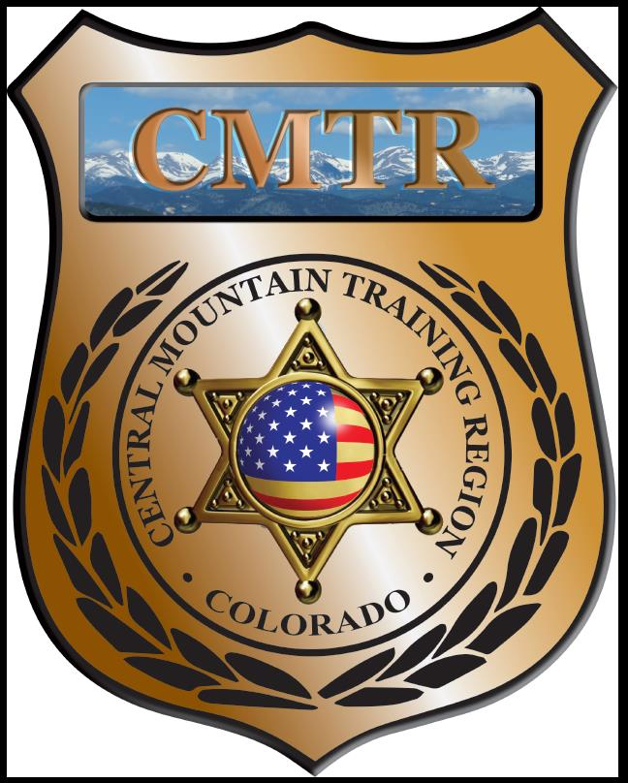

Meeting Agenda
November 14th, 2019
11:00am

Host:
Colorado Springs Police Department
725 N Murray Blvd
Colorado Springs, CO 80915
Meeting Agenda

CMTR Board Members
- President: Shelli Ellis Pueblo PD
- 1st Vice President: Shannon Byerly Custer County S.O.
- Secretary: Ryan Holzwarth Woodland Park PD
- Assistant Secretary: Russ Johnson Salida PD
- Voting Position: Bruce Briscoe Fremont County SO
- Voting Position: Chad Bauer Pikes Peak Community College
- Voting Position: Dave Clements Pueblo County SO
- Regional Training Coordinator: Jason Smith Pueblo PD

Welcome: New Faces and Guests
Treasurer’s Report: (Jason Smith)

Training
- Started with $131,810.00 ($178,476.00)
- Basic FTO ($8388.42), Crisis Negotiations ($14,090.97)
- Balance $118,602.40

Equipment
- Started with $20,991.00
- Fuel $95.50
- Balance $20,119.82

Scholarships
- Started with $30,000.00
- 3 scholarships were approved in October ($565)
- Remaining $15,296.00

Old Business
- Public Safety Leadership Development class
- FBI Command Leadership class (lower enrollment)
- Training Needs Analysis (Training,Leadership, and Change Management, LLC)

New Business
- Discussion on Driving Simulator
- Allocation of Grant money for Regions
- Training Needs

Training Request
Remaining Balance: $15,296.00
Request Total: $3,520

- From Agency: Canon City PD
  - For (Officer): Bryce Bodycomb
  - Class: Dignitary Protection Class
  - Date Requested: 10/08/19
  - Date(s): October 3rd & 4th, 2019
  - Location: Aurora, CO
  - Class Cost: $150
  - Lodging: $0
  - Per Diem: $0
    - To: Action:
  - Related Cost: $0

Total Cost: $150
Vote:
Ellis Y/N, Byerly Y/N, Holzwarth Y/N, Johnson Y/N, Briscoe Y/N, Bauer Y/N, Clements Y/N

- From Agency: Canon City PD
  - For (Officer): Ryan Belding
  - Class: Dignitary Protection Class
  - Date Requested: 10/08/19
  - Date(s): October 3rd & 4th, 2019
  - Location: Aurora, CO
  - Class Cost: $150
  - Lodging: $0
  - Per Diem: $0
    - To: Action:
  - Related Cost: $0

Total Cost: $150
Vote:
Ellis Y/N, Byerly Y/N, Holzwarth Y/N, Johnson Y/N, Briscoe Y/N, Bauer Y/N, Clements Y/N

- From Agency: Woodland Park PD
  - For (Officer): Timothy Bradley
  - Class: Force Science Institute
  - Date Requested: October 25th, 2019
  - Date(s): February 3-7, 2020
  - Location: Scottsdale, AZ
  - Class Cost: $1650
  - Lodging: $0
  - Per Diem: $0
    - To: Action:
  - Related Cost:

Total Cost: $1650
Vote:
Ellis Y/N, Byerly Y/N, Holzwarth Y/N, Johnson Y/N, Briscoe Y/N, Bauer Y/N, Clements Y/N

- From Agency: Canon City PD
  - For (Officer): Tim Walsh
  - Class: Writing Reports NIBRS style
  - Date Requested: 10/24/19
  - Date(s): November 15th, 2019
  - Location: Thornton, CO
  - Class Cost: $195
  - Lodging: $0
  - Per Diem: $0
    - To: Action:
  - Related Cost: $0

Total Cost: $195
Vote:
Ellis Y/N, Byerly Y/N, Holzwarth Y/N, Johnson Y/N, Briscoe Y/N, Bauer Y/N, Clements Y/N

- From Agency: Colorado Springs PD
  - For (Officer): Scott Acey
  - Class: Rangemaster Development
  - Date Requested: 11/05/19
  - Date(s): December 2-4th, 2019
  - Location: Ft Collins, CO
  - Class Cost: $425
  - Lodging: $0
  - Per Diem: $0
    - To: Action:
  - Related Cost: $0

Total Cost: $425
Vote:
Ellis Y/N, Byerly Y/N, Holzwarth Y/N, Johnson Y/N, Briscoe Y/N, Bauer Y/N, Clements Y/N

- From Agency: Pueblo PD
  - For (Officer): Marcus Juliano
  - Class: Digital Fugitive Apprehension
  - Date Requested: 11/06/19
  - Date(s): December 2-3rd, 2019
  - Location: Denver, CO
  - Class Cost: $475
  - Lodging: $0
  - Per Diem: $0
    - To: Action:
  - Related Cost: $0

Total Cost: $475
Vote:
Ellis Y/N, Byerly Y/N, Holzwarth Y/N, Johnson Y/N, Briscoe Y/N, Bauer Y/N, Clements Y/N

- From Agency: Pueblo PD
  - For (Officer): Brock Ruiz
  - Class: Digital Fugitive Apprehension
  - Date Requested: 11/12/19
  - Date(s): December 2-3rd, 2019
  - Location: Denver, CO
  - Class Cost: $475
  - Lodging: $0
  - Per Diem: $0
    - To: Action:
  - Related Cost: $0

Total Cost: $475
Vote:
Ellis Y/N, Byerly Y/N, Holzwarth Y/N, Johnson Y/N, Briscoe Y/N, Bauer Y/N, Clements Y/N

Other Items to Discuss:
Notes:___________________________________________________________________________________________________________________________________________________________________________________________________________________________________

Central Mountain Training Region
Meeting Schedule FY20
(First Thursday of the Month) Start Time 11:00am

December 5th, 2019 Location/Host:
No Meeting

January 2nd, 2020 Location/Host:
Pueblo Police Department
200 S Main St
Pueblo, CO 81003

March 5th, 2020 Location/Host:
Woodland Park PD
911 Tamarac Pkwy
Woodland Park, CO 80863
February 6th, 2020 Location/Host:
Pueblo County SO
101 W 10th St
Pueblo, CO 81003

May 7th, 2020 Location/Host:
Manitou Springs PD
606 Manitou Ave
Manitou Springs, CO 80829
April 2nd, 2020 Location/Host:
Pikes Peak Community College
5675 Academy Blvd
Colorado Springs, CO 80906

July 2nd, 2020 Location/Host:
TBA
June 4th, 2020 Location/Host:
TBA

September 3rd, 2020 Location/Host:
TBA
August 6th, 2020 Location/Host:
TBA

