Central Mountain Training Region

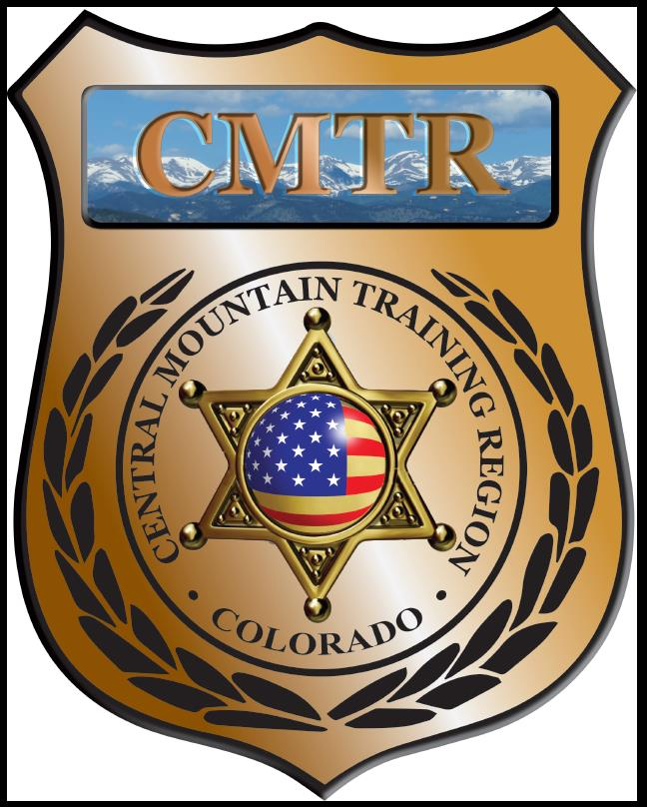

Meeting Agenda
December 6th, 2019
11:00am

Host:
No Meeting

