Central Mountain Training Region

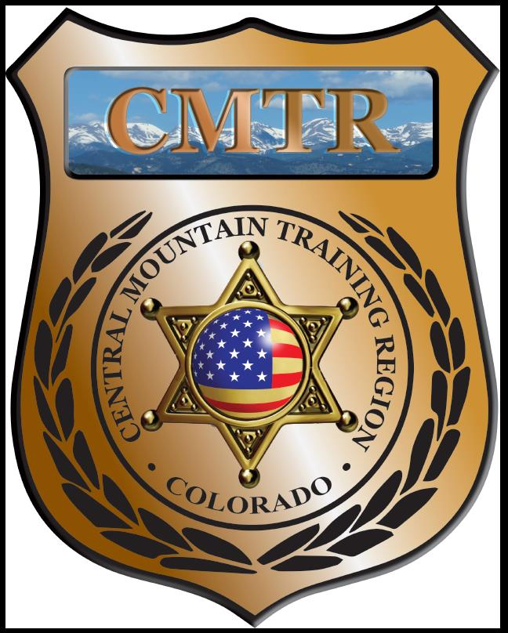

Meeting Agenda
January 2nd, 2019
11:00am

Host:
Pueblo Police Department
200 S Main St
Pueblo, CO 81003
Meeting Agenda

CMTR Board Members
- President: Shelli Ellis Pueblo PD
- 1st Vice President: Shannon Byerly Custer County S.O.
- Secretary: Ryan Holzwarth Woodland Park PD
- Assistant Secretary: Russ Johnson Salida PD
- Voting Position: Bruce Briscoe Fremont County SO
- Voting Position: Chad Bauer Pikes Peak Community College
- Voting Position: Dave Clements Pueblo County SO
- Regional Training Coordinator: Jason Smith Pueblo PD

Welcome: New Faces and Guests
Treasurer’s Report: (Jason Smith)

Training
- Started with $131,810.00 ($178,476.00)
- Level I TA ($6,576.73), Command Leadership Institute ($14,670)
- Balance $97,355.67

Equipment
- Started with $20,991.00
- Fuel $227.50, Ammo order ($4557)
- Balance $15,330.82

Scholarships
- Started with $30,000.00
- 7 scholarships were approved in November ($3520), 5 scholarships approved by Board email December ($3850)
- Remaining $7,652.00

Old Business
- Discussion on Driving Simulator (Canon City)
- Allocation of Grant money for Regions
- Training Needs

New Business
- 6 months in review
- Training Classes (Train the Trainers (I (4) & II (2))
- Woodland Park PD Driving Simulator upgrade ($3000) and indoor range maintenance ($4500)
- Monthly Meeting location

Training Request
Remaining Balance: $7652.00
Request Total: $950

- From Agency: Fountain PD
  - For (Officer): Charles Stage
  - Class: Level 2 TA
  - Date Requested: December 9th
  - Date(s): January 13-24, 2020
  - Location: Parker, CO
  - Class Cost: $950
  - Lodging: $0
  - Per Diem: $0
    - To: Action:
  - Related Cost: $0
Approved

Total Cost: $950
Vote:
Ellis Y/N, Byerly Y/N, Holzwarth Y/N, Johnson Y/N, Briscoe Y/N, Bauer Y/N, Clements Y/N
- From Agency: Manitou Springs PD
  - For (Officer): Paul Van Bemden
  - Class: Level 2 TA
  - Date Requested: December 9th
  - Date(s): January 13-24, 2020
  - Location: Parker, CO
  - Class Cost: $950
  - Lodging: $0
  - Per Diem: $0
    - To: Action:
  - Related Cost: $0
Approved

Total Cost: $950
Vote:
Ellis Y/N, Byerly Y/N, Holzwarth Y/N, Johnson Y/N, Briscoe Y/N, Bauer Y/N, Clements Y/N

Other Items to Discuss:
Notes:___________________________________________________________________________________________________________________________________________________________________________________________________________________________________

Central Mountain Training Region
Meeting Schedule FY20
(First Thursday of the Month) Start Time 11:00am

March 5th, 2020 Location/Host:
Woodland Park PD
911 Tamarac Pkwy
Woodland Park, CO 80863
February 6th, 2020 Location/Host:
Pueblo County SO
101 W 10th St
Pueblo, CO 81003

May 7th, 2020 Location/Host:
Manitou Springs PD
606 Manitou Ave
Manitou Springs, CO 80829
April 2nd, 2020 Location/Host:
Pikes Peak Community College
5675 Academy Blvd
Colorado Springs, CO 80906

July 2nd, 2020 Location/Host:
TBA
June 4th, 2020 Location/Host:
TBA

September 3rd, 2020 Location/Host:
TBA
August 6th, 2020 Location/Host:
TBA

November 5th, 2020 Location/Host:
TBA
October 1st, 2020 Location/Host:
TBA

