Central Mountain Training Region

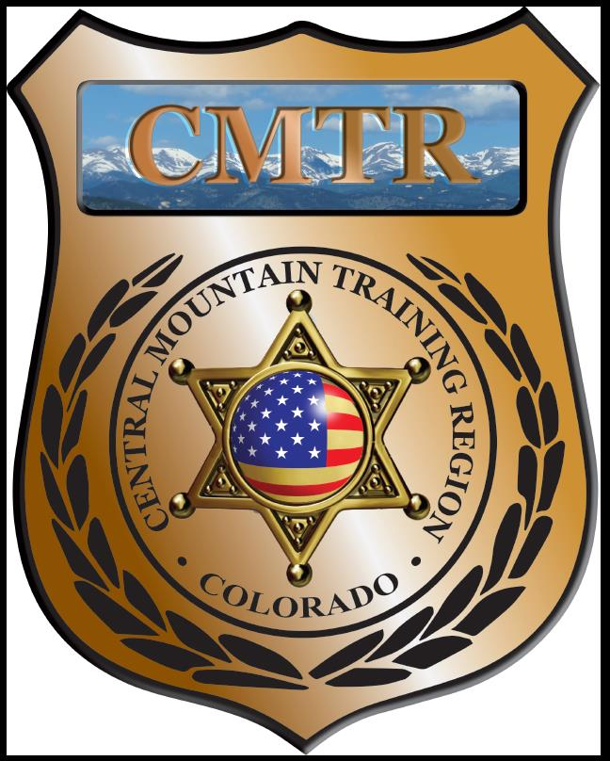

Meeting Agenda
February 6th, 2020
11:00am

Host:
Pueblo County Sheriff’s Office
101 W 10th St
Pueblo, CO 81003
Meeting Agenda

CMTR Board Members
- President: Shelli Ellis Pueblo PD
- 1st Vice President: Shannon Byerly Custer County S.O.
- Secretary: Ryan Holzwarth Woodland Park PD
- Assistant Secretary: Russ Johnson Salida PD
- Voting Position: Bruce Briscoe Fremont County SO
- Voting Position: Chad Bauer Pikes Peak Community College
- Voting Position: Dave Clements Pueblo County SO
- Regional Training Coordinator: Jason Smith Pueblo PD

Welcome: New Faces and Guests
Treasurer’s Report: (Jason Smith)

Training
- Started with $131,810.00 ($178,476.00)
- Building Scenarios ($2066.87), Human Factors ($490.43)
- Balance $95,215.14

Equipment
- Started with $20,991.00
- Fuel $107.50, Ammo order ($4557), UTM ammo ($2,555.95)
- Balance $9,467.37

Scholarships
- Started with $30,000.00
- 2 scholarships approved by Board email January ($1900)
- Remaining $6,702

Old Business
- 6 months in review
- Training Classes (Train the Trainers (I (4) & II (2))-cancelled
- Woodland Park PD Driving Simulator upgrade-Approved ($3000) and indoor range maintenance Denied ($4500)
- Monthly Meeting location

New Business
- Stakeholders meeting
- Upcoming Classess; DU-PSLP (February), Driving Instructor (March), Basic Patrol Rifle (March), Handgun Instructor (April), Instructor Methodology (April)
- CIT class in June at Fremont County SO
- Needs Analysis returned

Training Request
Remaining Balance: $6702.00
Request Total: $9124

- From Agency: Pueblo PD
  - For (Officer): Shawn Davis
  - Class: Homicide Investigation
  - Date Requested: January 2nd
  - Date(s): May 4-15, 2020
  - Location: South Carolina
  - Class Cost: $1334
  - Lodging: $0
  - Per Diem: $0
    - To: Action:
  - Related Cost: $0
Approved

Total Cost: $1334
Vote:
Ellis Y/N, Byerly Y/N, Holzwarth Y/N, Johnson Y/N, Briscoe Y/N, Bauer Y/N, Clements Y/N

- From Agency: Canon City PD
  - For (Officer): Tammy Wagner
  - Class: SPI Organizational Leadership
  - Date Requested: January 6th
  - Date(s): February 17-21, 2020
  - Location: Jeffersonville, IN
  - Class Cost: $795
  - Lodging: $0
  - Per Diem: $0
    - To: Action:
  - Related Cost: $0
Approved

Total Cost: $795
Vote:
Ellis Y/N, Byerly Y/N, Holzwarth Y/N, Johnson Y/N, Briscoe Y/N, Bauer Y/N, Clements Y/N

- From Agency: Canon City PD
  - For (Officer): Shelby Beck
  - Class: Reid Technique of Interviewing
  - Date Requested: December 9th
  - Date(s): February 11-14, 2020
  - Location: Greenwood Village, CO
  - Class Cost: $795
  - Lodging: $0
  - Per Diem: $0
    - To: Action:
  - Related Cost: $0
Tammy took it out of the running

Total Cost: $795
Vote:
Ellis Y/N, Byerly Y/N, Holzwarth Y/N, Johnson Y/N, Briscoe Y/N, Bauer Y/N, Clements Y/N

- From Agency: Pueblo PD
  - For (Officer): David Woods
  - Class: Leadership for Challenging Times
  - Date Requested: January 14th
  - Date(s): March 10-12, 2020
  - Location: Denver, CO
  - Class Cost: $350
  - Lodging: $0
  - Per Diem: $0
    - To: Action:
  - Related Cost: $0
Approved

Total Cost: $350
Vote:
Ellis Y/N, Byerly Y/N, Holzwarth Y/N, Johnson Y/N, Briscoe Y/N, Bauer Y/N, Clements Y/N

- From Agency: Manitou Springs PD
  - For (Officer): Dacona Coombs
  - Class: Reid Interview
  - Date Requested: January 14th
  - Date(s): February 11-14, 2020
  - Location: Greenwood Village, CO
  - Class Cost: $695
  - Lodging: $0
  - Per Diem: $0
    - To: Action:
  - Related Cost: $0
Approved

Total Cost: $695
Vote:
Ellis Y/N, Byerly Y/N, Holzwarth Y/N, Johnson Y/N, Briscoe Y/N, Bauer Y/N, Clements Y/N

- From Agency: Manitou Springs PD
  - For (Officer): Leo Strand
  - Class: Reid Interview
  - Date Requested: January 14th
  - Date(s): February 11-14, 2020
  - Location: Greenwood Village, CO
  - Class Cost: $695
  - Lodging: $0
  - Per Diem: $0
    - To: Action:
  - Related Cost: $0
Approved

Total Cost: $695
Vote:
Ellis Y/N, Byerly Y/N, Holzwarth Y/N, Johnson Y/N, Briscoe Y/N, Bauer Y/N, Clements Y/N

- From Agency: Pueblo PD
  - For (Officer): Justin Preedy
  - Class: FBI LEEDA Supervisor Leadership Institute
  - Date Requested: January 30th
  - Date(s): May 11-15, 2020
  - Location: Boulder, CO
  - Class Cost: $695
  - Lodging: $0
  - Per Diem: $0
    - To: Action:
  - Related Cost: $0
Denied

Total Cost: $500
Vote:
Ellis Y/N, Byerly Y/N, Holzwarth Y/N, Johnson Y/N, Briscoe Y/N, Bauer Y/N, Clements Y/N

- From Agency: Pueblo PD
  - For (Officer): Stephen Perez
  - Class: Bloodstain Pattern Analysis I
  - Date Requested: January 17th
  - Date(s): June 1-5, 2020
  - Location: Colorado Springs, CO
  - Class Cost: $655
  - Lodging: $0
  - Per Diem: $0
    - To: Action:
  - Related Cost: $0
Approved

Total Cost: $655
Vote:
Ellis Y/N, Byerly Y/N, Holzwarth Y/N, Johnson Y/N, Briscoe Y/N, Bauer Y/N, Clements Y/N

- From Agency: Pueblo PD
  - For (Officer): John Trivett
  - Class: Intro to Science of Friction Ridge Exam
  - Date Requested: January 17th
  - Date(s): June 8-12, 2020
  - Location: Golden, CO
  - Class Cost: $600
  - Lodging: $0
  - Per Diem: $0
    - To: Action:
  - Related Cost: $0
Approved

Total Cost: $600
Vote:
Ellis Y/N, Byerly Y/N, Holzwarth Y/N, Johnson Y/N, Briscoe Y/N, Bauer Y/N, Clements Y/N

- From Agency: Cripple Creek PD
  - For (Officer): Robert Hill
  - Class: FBI LEEDA- Executive Leadership
  - Date Requested: January 15th
  - Date(s): February 10-14, 2020
  - Location: Parker, CO
  - Class Cost: $0
  - Lodging: $425
  - Per Diem: $0
    - To: Action:
  - Related Cost: $0
Denied

Total Cost: $425
Vote:
Ellis Y/N, Byerly Y/N, Holzwarth Y/N, Johnson Y/N, Briscoe Y/N, Bauer Y/N, Clements Y/N

- From Agency: Woodland Park PD
  - For (Officer): Andy Leibbrand, Mike McDaniel and Shannon Everhart
  - Class: Reid Technique
  - Date Requested: January 30th
  - Date(s): February 11-14, 2020
  - Location: Greenwood Village, CO
  - Class Cost: $2085 ($695 each)
  - Lodging: $0
  - Per Diem: $0
    - To: Action:
  - Related Cost: $0
All 3 Approved

Total Cost: $
Vote:
Ellis Y/N, Byerly Y/N, Holzwarth Y/N, Johnson Y/N, Briscoe Y/N, Bauer Y/N, Clements Y/N

Other Items to Discuss:
Notes:___________________________________________________________________________________________________________________________________________________________________________________________________________________________________

Central Mountain Training Region
Meeting Schedule FY20
(First Thursday of the Month) Start Time 11:00am

April 2nd, 2020 Location/Host:
Pikes Peak Community College
5675 Academy Blvd
Colorado Springs, CO 80906
March 5th, 2020 Location/Host:
Woodland Park PD
911 Tamarac Pkwy
Woodland Park, CO 80863

June 4th, 2020 Location/Host:
Fountain PD

May 7th, 2020 Location/Host:
Manitou Springs PD
606 Manitou Ave
Manitou Springs, CO 80829

July 2nd, 2020 Location/Host:
Custer County SO
702 Rosita Ave
Westcliffe, CO 81252
August 6th, 2020 Location/Host:
Colorado Springs Training Academy
725 N Murray Blvd
Colorado Springs, CO 80915

October 1st, 2020 Location/Host:
Fremont County SO
September 3rd, 2020 Location/Host:
Canon City PD
128 Main St
Canon City, CO 81212

December, 2020 Location/Host:
No Meeting
November 5th, 2020 Location/Host:
Salida Police Department
448 E 1st St
Salida, CO 81201

