Central Mountain Training Region

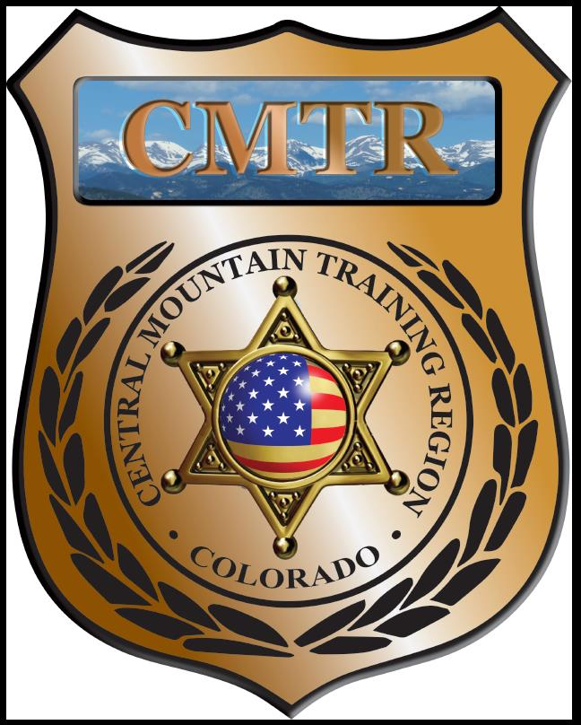

Meeting Agenda
April 2nd, 2020
11:00am

Host:
Virtual Meeting-Zoom

Meeting Agenda

CMTR Board Members
- President: Shelli Ellis Pueblo PD
- 1st Vice President: Shannon Byerly Custer County S.O.
- Secretary: Ryan Holzwarth Woodland Park PD
- Assistant Secretary: Russ Johnson Salida PD
- Voting Position: Bruce Briscoe Fremont County SO
- Voting Position: Chad Bauer Pikes Peak Community College
- Voting Position: Dave Clements Pueblo County SO
- Regional Training Coordinator: Jason Smith Pueblo PD

Welcome: New Faces and Guests
Treasurer’s Report: (Jason Smith)

Training
- Started with $131,810.00 ($178,476.00)
- Balance $44,309.39

Equipment
- Started with $20,991.00
- Fuel $73.50, UTM ammo ($1,184.57), Grant Mod. ($6,076.87)
- Balance $5,250.95

Scholarships
- Started with $30,000.00
- 6 scholarships approved by Board March ($1326)
- Waiting to transfer $424 from Training or Equipment
- Remaining $0

Old Business
- CIT Class at UCCS, Verbal Fitness & De-Ecalation class
- Upcoming CMTR classes; Driving Instructor, Basic Patrol Rifle, Train the Trainer, Adv Carbine, Human Factors and Auto v. Ped.
- FY21 budget
- New classes

New Business
- Remaining classes; DU-Leadership (April), Red Dot (April), Adv Carbine (May), Human Factors (May), CIT (June) and Handgun Instructor (June)
- FY21 budget $228,834.00 ($198,986 for Training, Equipment & Scholarships)

Training Request
Remaining Balance: $0
Request Total: $0

Other Items to Discuss:
Notes:__________________________________________________________________________________________________________________________________________________________________________________________________________________________________

Central Mountain Training Region
Meeting Schedule FY20
(First Thursday of the Month) Start Time 11:00am

May 7th, 2020 Location/Host:
Manitou Springs PD
606 Manitou Ave
Manitou Springs, CO 80829
April 2nd, 2020 Location/Host:
Pikes Peak Community College
5675 Academy Blvd
Colorado Springs, CO 80906

July 2nd, 2020 Location/Host:
Custer County SO
702 Rosita Ave
Westcliffe, CO 81252
June 4th, 2020 Location/Host:
Fountain PD

September 3rd, 2020 Location/Host:
Canon City PD
128 Main St
Canon City, CO 81212
August 6th, 2020 Location/Host:
Colorado Springs Training Academy
725 N Murray Blvd
Colorado Springs, CO 80915

November 5th, 2020 Location/Host:
Salida Police Department
448 E 1st St
Salida, CO 81201
October 1st, 2020 Location/Host:
Fremont County SO

December, 2020 Location/Host:
No Meeting

