Central Mountain Training Region

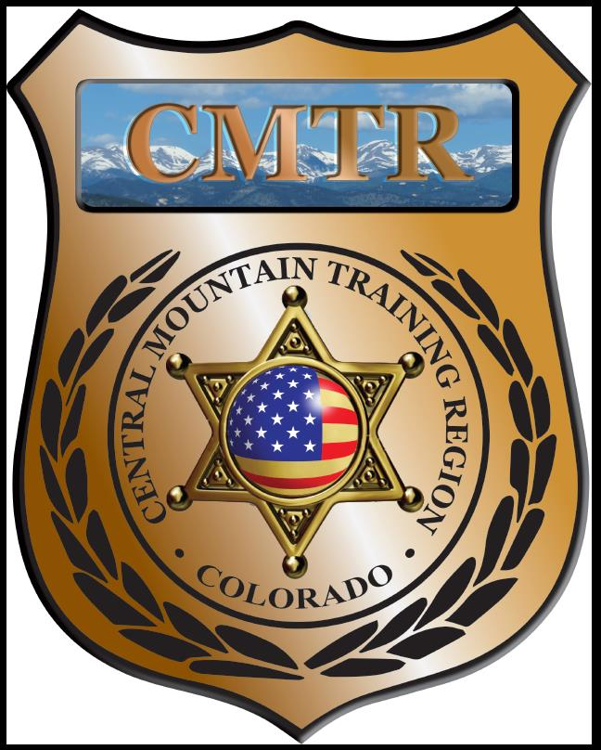

Meeting Agenda
May 7th, 2020
11:00am

Host:
Virtual Meeting-Zoom

Meeting Agenda

CMTR Board Members
- President: Shelli Ellis Pueblo PD
- 1st Vice President: Shannon Byerly Custer County S.O.
- Secretary: Ryan Holzwarth Woodland Park PD
- Assistant Secretary: Russ Johnson Salida PD
- Voting Position: Bruce Briscoe Fremont County SO
- Voting Position: Chad Bauer Pikes Peak Community College
- Voting Position: Dave Clements Pueblo County SO
- Regional Training Coordinator: Jason Smith Pueblo PD

Welcome: New Faces and Guests
Treasurer’s Report: (Jason Smith)

Training
- Started with $131,810.00 ($178,476.00)
- Balance $37,238.60

Equipment
- Started with $20,991.00
- Fuel ($64), Simunation Kits & Ammo ($7,768)
- Balance $8,259.35

Scholarships
- Started with $30,000.00
- Cancelled scholarships (Pueblo PD, Fremont SO and Manitou Springs PD)
- Total Spent $27,543
- Remaining $2457

Old Business
- Remaining classes; DU-Leadership (April), Red Dot (April), Adv Carbine (May), Human Factors (May), CIT (June) and Handgun Instructor (June)
- FY21 budget $228,834.00 ($198,986 for Training, Equipment & Scholarships)

New Business
- Chief of Alma, Joseph Behrman, looking to buy used Patrol Vehicle, all wheel or 4 wheel drive, and equipment.
- Plan on using left over budget to purchase ammunition.
- May 11th at 1pm Zoom meeting with POST to look over proposed revisions for Grant Agreement primarily with “Sub-Contractors”
- June 8th Grants should be out to regions for FY21
- Remaining classes (Auto vs Ped, CIT, Handgun Instructor)
- Open Board positions (V. President and Voting Position)

Training Request
Remaining Balance: $0
Request Total: $0

Other Items to Discuss:
Notes:__________________________________________________________________________________________________________________________________________________________________________________________________________________________________

Central Mountain Training Region
Meeting Schedule FY20
(First Thursday of the Month) Start Time 11:00am

July 2nd, 2020 Location/Host:
Custer County SO
702 Rosita Ave
Westcliffe, CO 81252
June 4th, 2020 Location/Host:
Fountain PD
222 N Santa Fe Ave
Fountain, CO 80817

September 3rd, 2020 Location/Host:
Canon City PD
128 Main St
Canon City, CO 81212
August 6th, 2020 Location/Host:
Colorado Springs Training Academy
725 N Murray Blvd
Colorado Springs, CO 80915

November 5th, 2020 Location/Host:
Salida Police Department
448 E 1st St
Salida, CO 81201
October 1st, 2020 Location/Host:
Fremont County SO

January, 2020 Location/Host:
December, 2020 Location/Host:
No Meeting

March, 2020 Location/Host:

February, 2020 Location/Host:

