Central Mountain Training Region

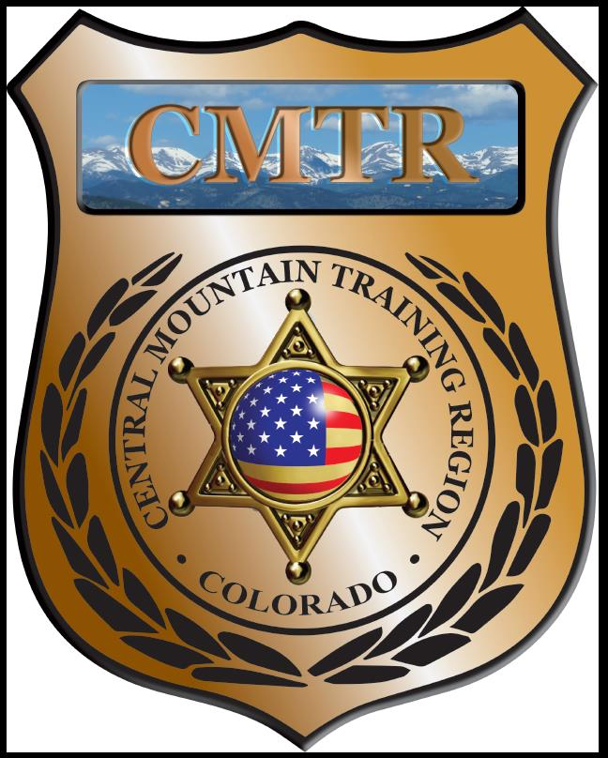

Meeting Agenda
June 4th, 2020
11:00am

Host:
Custer County SO
710 Rosita Ave
Westcliffe, CO

Meeting Agenda

CMTR Board Members
- President: Shelli Ellis Pueblo PD
- 1st Vice President: Shannon Byerly Custer County S.O.
- Secretary: Ryan Holzwarth Woodland Park PD
- Assistant Secretary: Russ Johnson Salida PD
- Voting Position: Bruce Briscoe Fremont County SO
- Voting Position: Chad Bauer Pikes Peak Community College
- Voting Position: Dave Clements Pueblo County SO
- Regional Training Coordinator: Jason Smith Pueblo PD

Welcome: New Faces and Guests
Treasurer’s Report: (Jason Smith)

Training
- Started with $131,810.00 ($178,476.00)
- Adv Carbine ($3,417.06), Auto v Ped ($9,426.98), Moved $793 to Equip
- Balance $23,754.59

Equipment
- Started with $20,991.00
- Moved $3000 to equipment from Scholarships & Training, Ammo purchase ($3,625), BC zone steel target ($273.99), Range 1 Weed Control ($450), Lowes ($4.76), Fuel ($101)
- Balance $3,942.60

Scholarships
- Started with $30,000.00
- Total Spent $29,750
- Moved $2207 to equipment (Driving Simulator)
- Remaining $250

Old Business
- Chief of Alma, Joseph Behrman, looking to buy used Patrol Vehicle, all wheel or 4 wheel drive, and equipment.
- Plan on using left over budget to purchase ammunition.
- May 11th at 1pm Zoom meeting with POST to look over proposed revisions for Grant Agreement primarily with “Sub-Contractors”
- June 8th Grants should be out to regions for FY21
- Remaining classes (Auto vs Ped, CIT, Handgun Instructor)
- Open Board positions (V. President and Voting Position)

New Business
- Grant Agreement meeting on May 11th (Sub-Contractors)
- 4th Quarter report due July 7th
- FY 21 Grant from POST June 8th , grant updated budget
- Vote for new members (V.P and Voting Member)

Training Request
Remaining Balance: $0
Request Total: $0

Other Items to Discuss:
Notes:__________________________________________________________________________________________________________________________________________________________________________________________________________________________________

Central Mountain Training Region
Meeting Schedule FY20
(First Thursday of the Month) Start Time 11:00am

August 6th, 2020 Location/Host:
Colorado Springs Training Academy
725 N Murray Blvd
Colorado Springs, CO 80915
July 2nd, 2020 Location/Host:
Pueblo PD
200 S Main St
Pueblo, CO 81003

October 1st, 2020 Location/Host:
Fremont County SO
September 3rd, 2020 Location/Host:
Canon City PD
128 Main St
Canon City, CO 81212

December, 2020 Location/Host:
No Meeting
November 5th, 2020 Location/Host:
Salida Police Department
448 E 1st St
Salida, CO 81201

February, 2020 Location/Host:

January, 2020 Location/Host:
Pueblo Police Department
200 S Main St
Pueblo, CO 81003

June 4th, 2020 Location/Host:

March, 2020 Location/Host:

