Central Mountain Training Region

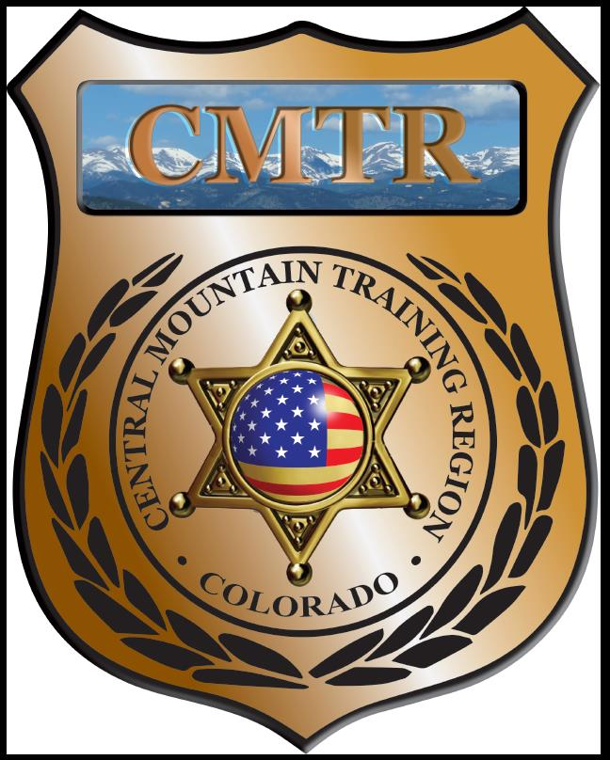

Meeting Agenda
July 9th, 2020
11:00am

Host:
Pueblo PD
200 S Main St
Pueblo, CO 81003
Meeting Agenda

CMTR Board Members
- President: Shannon Byerly Custer County S.O.
- 1st Vice President: Chad Bauer Pikes Peak Community College
- Secretary: Ryan Holzwarth Woodland Park PD
- Assistant Secretary: Russ Johnson Salida PD
- Voting Position: Bruce Briscoe Fremont County SO
- Voting Position: Zach Ballas Pueblo PD
- Voting Position: Dan Wells Pueblo County SO
- Regional Training Coordinator: Jason Smith Pueblo PD

Welcome: New Faces and Guests
Treasurer’s Report: (Jason Smith)

Training
- Started with $131,810.00 ($178,476.00)
- CIT ($15,347.90, Handgun Instructor ($1,111.17), Moved $4098.35 to Equip
- Balance $0
- Actual spent $169,554.73

Equipment
- Started with $20,991.00
- Lumber ($246.43), Wheel Chock ($14.99), Ammunition ($7,478.73), Battery ($54.88)
- Balance $1.96
- Actual spent $32,607.31

Scholarships
- Started with $30,000.00
- Balance $0
- Actual spent $27,303

Total Spent (Training, Equipment & Scholarships) for FY20 $229,465.04

Old Business
- Grant Agreement meeting on May 11th (Sub-Contractors)
- 4th Quarter report due July 7th
- FY 21 Grant from POST June 8th , grant updated budget
- Vote for new members (V.P and Voting Member)

New Business
- New Grant start July 13th
- Training $107,499.00
- Equipment $5,841.00
- Scholarships $20,000.00
- Grant Management $6,667.00
- Program Delivery $13,334.00
- Total $153,341.00
- Grant Modification: moving $7,000 from Scholarships to Training for Interview & Interrogation
- Classes start in August; Basic SWAT School (Aug 3-7), Reno PTO (10-14), Legally Justified (Aug 25)

Other Items to Discuss:
Notes:_Motion to move minutes to the second Thursday of the month was passed._ __________________________________________________________________________________________________________

Training Request
Remaining Balance: $20,000

- From Agency: Custer County SO
  - For (Officer): Michael Kear
  - Class: Desert Snow
  - Date Requested: 06/16/20
  - Date(s): September 1st-3rd, 2020
  - Location: Golden, CO
  - Class Cost: $599
  - Lodging: $0
  - Per Diem: $0
    - To: Action:
  - Related Cost: $0
Approved

Total Cost: $599

Vote:
Byerly Y/N, Bauer Y/N, Holzwarth Y/N, Johnson Y/N, Briscoe Y/N, Ballas Y/N, Wells Y/N

- From Agency: Custer County SO
  - For (Officer): Greg Reeve
  - Class: Desert Snow
  - Date Requested: 06/16/20
  - Date(s): September 1st-3rd, 2020
  - Location: Golden, CO
  - Class Cost: $599
  - Lodging: $0
  - Per Diem: $0
    - To: Action:
  - Related Cost: $0
Cancelled/Bylerly

Total Cost: $599

Vote:
Byerly Y/N, Bauer Y/N, Holzwarth Y/N, Johnson Y/N, Briscoe Y/N, Ballas Y/N, Wells Y/N

- From Agency: Pikes Peak CC
  - For (Officer): Vaalele Maluia
  - Class: NRA Range Safety Officer
  - Date Requested: 07/06/20
  - Date(s): July 12th, 2020
  - Location: Colorado Springs, CO
  - Class Cost: $125
  - Lodging: $0
  - Per Diem: $0
    - To: Action:
  - Related Cost:
Denied/training before sign grant

Total Cost: $125

Vote:
Byerly Y/N, Bauer Y/N, Holzwarth Y/N, Johnson Y/N, Briscoe Y/N, Ballas Y/N, Wells Y/N

- From Agency: Pikes Peak CC
  - For (Officer): Doyle Kilgore
  - Class: NRA Range Safety Officer
  - Date Requested: 07/06/20
  - Date(s): July 12th, 2020
  - Location: Colorado Springs, CO
  - Class Cost: $125
  - Lodging: $0
  - Per Diem: $0
    - To: Action:
  - Related Cost:
Denied/training before sign grant

Total Cost: $125

Vote:
Byerly Y/N, Bauer Y/N, Holzwarth Y/N, Johnson Y/N, Briscoe Y/N, Ballas Y/N, Wells Y/N
Request Total: $1448

Central Mountain Training Region
Meeting Schedule FY21
(First Thursday of the Month) Start Time 11:00am

September 10th, 2020 Location/Host:
Canon City PD
128 Main St
Canon City, CO 81212
August 13th, 2020 Location/Host:
Fountain PD
222 N Santa Fe Dr
Fountain, CO 80817

November 12th, 2020 Location/Host:
Salida Police Department
448 E 1st St
Salida, CO 81201
October 8th, 2020 Location/Host:
Fremont County SO

January, 2021 Location/Host:
Pueblo Police Department
200 S Main St
Pueblo, CO 81003
December, 2020 Location/Host:
No Meeting

March, 2021 Location/Host:

February, 2021 Location/Host:

July, 2021 Location/Host:
Custer County SO
June, 2021 Location/Host:

