Central Mountain Training Region

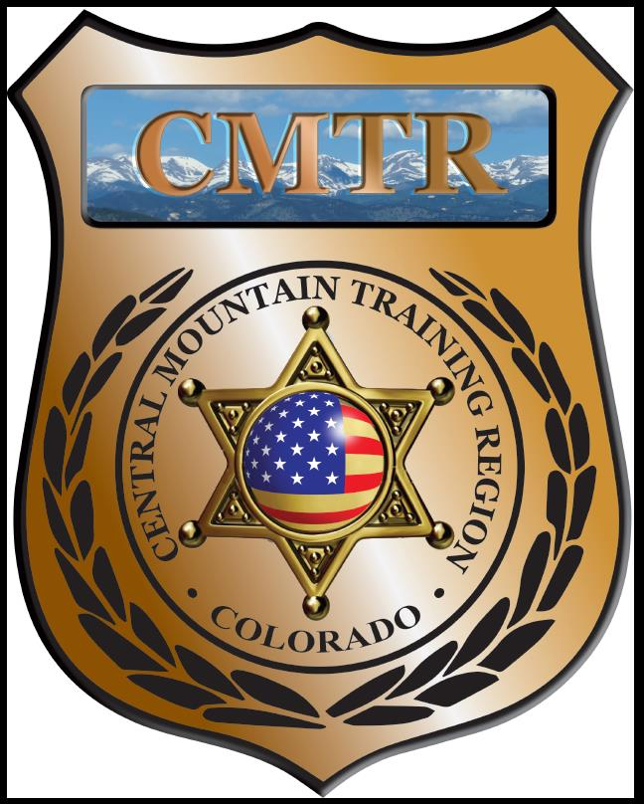

Meeting Agenda
August 13th, 2020
11:00am

Host:
Woodland Park Police Department
911 Tamarac Pkwy
Woodland Park, CO 80863
Meeting Agenda

CMTR Board Members
- President: Shannon Byerly Custer County S.O.
- 1st Vice President: Chad Bauer Pikes Peak Community College
- Secretary: Ryan Holzwarth Woodland Park PD
- Assistant Secretary: Russ Johnson Salida PD
- Voting Position: Bruce Briscoe Fremont County SO
- Voting Position: Zach Ballas Pueblo PD
- Voting Position: Dan Wells Pueblo County SO
- Regional Training Coordinator: Jason Smith Pueblo PD

Welcome: New Faces and Guests
Treasurer’s Report: (Jason Smith)

Training
- Started with $107,499.00
- Basic SWAT School ($1919.60)
- Remaining $105,579.40

Equipment
- Started with $5,841.00
- Remaining $5,841.00

Scholarships
- Started with $20,000.00
- Grant Modification of $7,000 to Training, 1 scholarship $599
- Actual spent $7,599
- Remaining $12,401

Old Business
- New Grant start July 13th
- Training $107,499.00
- Equipment $5,841.00
- Scholarships $20,000.00
- Grant Management $6,667.00
- Program Delivery $13,334.00
- Total $153,341.00
- Grant Modification: moving $7,000 from Scholarships to Training for Interview & Interrogation
- Classes start in August; Basic SWAT School (Aug 3-7), Reno PTO (10-14), Legally Justified (Aug 25)

New Business
- Custer County asking for 1000 UTX rounds for In-service training
- Pueblo County SO asking for 250 rounds UTX for SWAT Team training.
- Sub-Contractor Insurance
- Training Opportunities; Legally Justified, Constitutional UOF, Human Factors Legal Application of UOF and Instructor Methodology.
- Hosting Detention Skills Mini-Academy
- Meeting locations for rest of FY21

Other Items to Discuss:
Notes: __________________________________________________________________________________________________________
Training Request
Remaining Balance: $14,401

- From Agency: Cripple Creek PD
  - For (Officer): Kourtney Baker-Gomez
  - Class: Basic SRO
  - Date Requested: 08/09/20
  - Date(s): October 12-16, 2020
  - Location: Littleton, CO
  - Class Cost: $495
  - Lodging: $309.96
  - Per Diem: $0
    - To: Action:
  - Related Cost: $0
Approved

Total Cost: $495

Vote:
Byerly Y/N, Bauer Y/N, Holzwarth Y/N, Johnson Y/N, Briscoe Y/N, Ballas Y/N, Wells Y/N

Request Total: $495
Central Mountain Training Region
Meeting Schedule FY21
(First Thursday of the Month) Start Time 11:00am

September 10th, 2020 Location/Host:
Canon City PD
128 Main St
Canon City, CO 81212
October 8th, 2020 Location/Host:
Fremont County SO
201 N 6th St
Canon City, CO 81212

December, 2020 Location/Host:
No Meeting
November 12th, 2020 Location/Host:
Salida Police Department
448 E 1st St
Salida, CO 81201

February 11th, 2021 Location/Host:

January 14th, 2021 Location/Host:
Pueblo Police Department
200 S Main St
Pueblo, CO 81003

April 8th, 2021 Location/Host:

March 11th, 2021 Location/Host:

June 10th, 2020 Location/Host:

May 13th, 2021 Location/Host:
Custer County SO
710 Rosita Ave
Westcliffe, CO

