Central Mountain Training Region

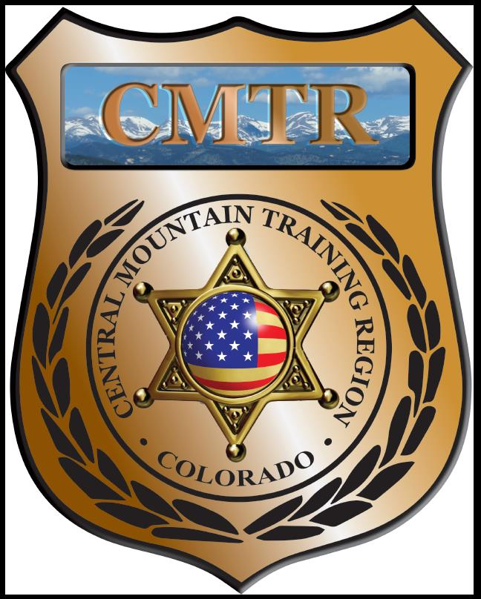

Meeting Agenda
September 10th, 2020
11:00am

Host:
Canon City Police Department
1145 Ohio
Canon City, CO 81212
Meeting Agenda

CMTR Board Members
- President: Shannon Byerly Custer County S.O.
- 1st Vice President: Chad Bauer Pikes Peak Community College
- Secretary: Ryan Holzwarth Woodland Park PD
- Assistant Secretary: Russ Johnson Salida PD
- Voting Position: Bruce Briscoe Fremont County SO
- Voting Position: Zach Ballas Pueblo PD
- Voting Position: Dan Wells Pueblo County SO
- Regional Training Coordinator: Jason Smith Pueblo PD

Welcome: New Faces and Guests
Treasurer’s Report: (Jason Smith)

Training
- Started with $107,499.00 (Revised $114,499.00)
- Legally Justified $6,641.62, Constitutional UOF $6520.87
- Remaining $101,328.51

Equipment
- Started with $5,841.00
- Lowe’s $3.20, Fuel $104.50
- Remaining $5,733.30

Scholarships
- Started with $20,000.00
- Approved 1 scholarship ($495) at August meeting
- Actual spent $8,094.00
- Remaining $11,906.00

Old Business
- Custer County asking for 1000 UTX rounds for In-service training
- Pueblo County SO asking for 250 rounds UTX for SWAT Team training.
- Sub-Contractor Insurance
- Training Opportunities; Legally Justified, Constitutional UOF, Human Factors Legal Application of UOF and Instructor Methodology.
- Hosting Detention Skills Mini-Academy
- Meeting locations for rest of FY21

New Business
- Training webinar’s
- Upcoming training
- Woodland Park PD Indoor Range cleanup $3,728.00
- October meeting

Other Items to Discuss:
Notes: __________________________________________________________________________________________________________
Central Mountain Training Region
Meeting Schedule FY21
(First Thursday of the Month) Start Time 11:00am
November 12th, 2020 Location/Host:
Salida Police Department
448 E 1st St
Salida, CO 81201
October 8th, 2020 Location/Host:
Fremont County SO
201 N 6th St
Canon City, CO 81212

January 14th, 2021 Location/Host:
Pueblo Police Department
200 S Main St
Pueblo, CO 81003
December, 2020 Location/Host:
No Meeting

March 11th, 2021 Location/Host:
Manitou Springs Police Department
February 11th, 2021 Location/Host:
Colorado Springs Police Department

May 13th, 2021 Location/Host:
Custer County SO
710 Rosita Ave
Westcliffe, CO
April 8th, 2021 Location/Host:
Canon City Police Department

July , 2020 Location/Host:

June 10th, 2021 Location/Host:
Woodland Park Police Department

